## GBD estimates used in comparison

<https://www.thelancet.com/journals/lancet/article/PIIS0140-6736(24)00476-8/fulltext#supplementary-material>

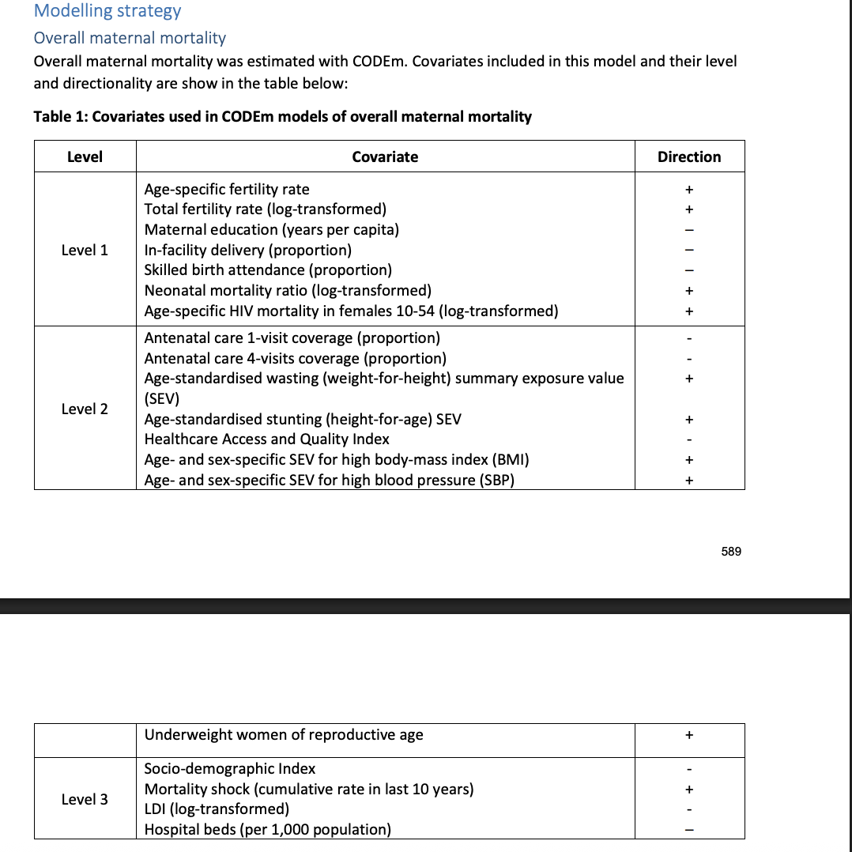

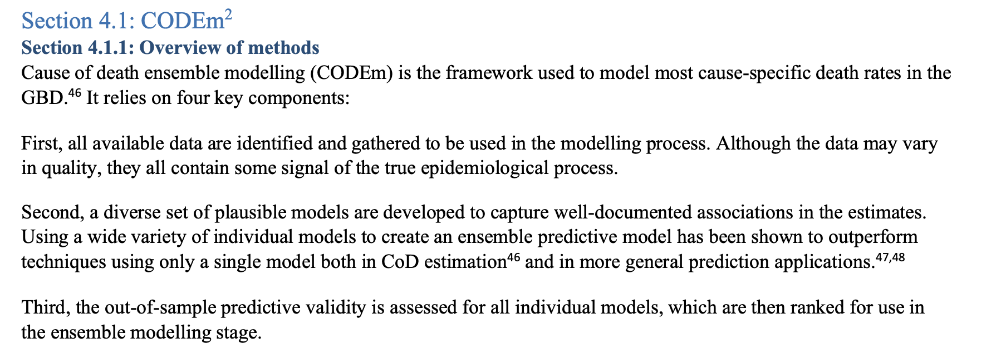 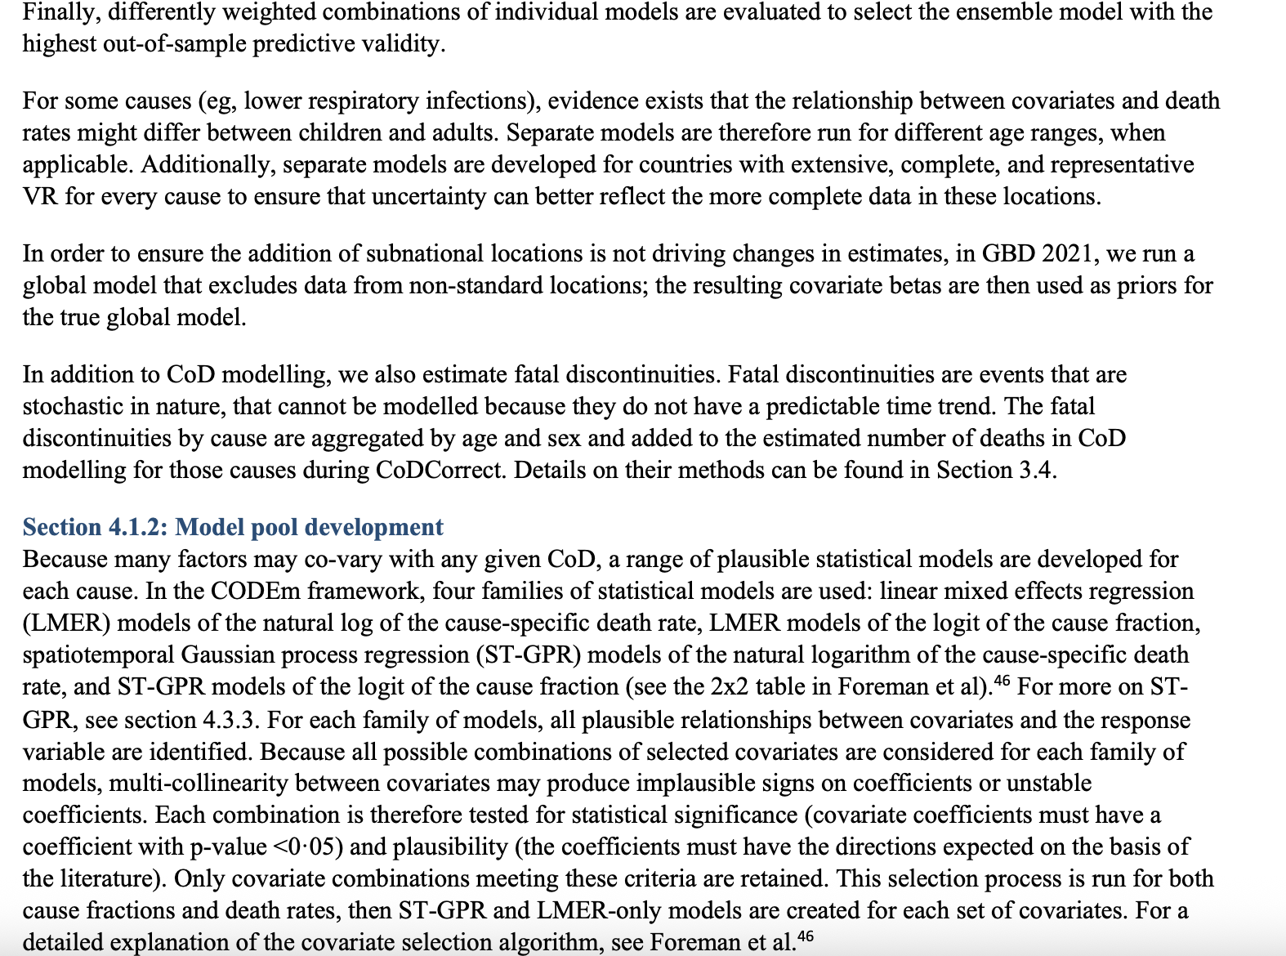 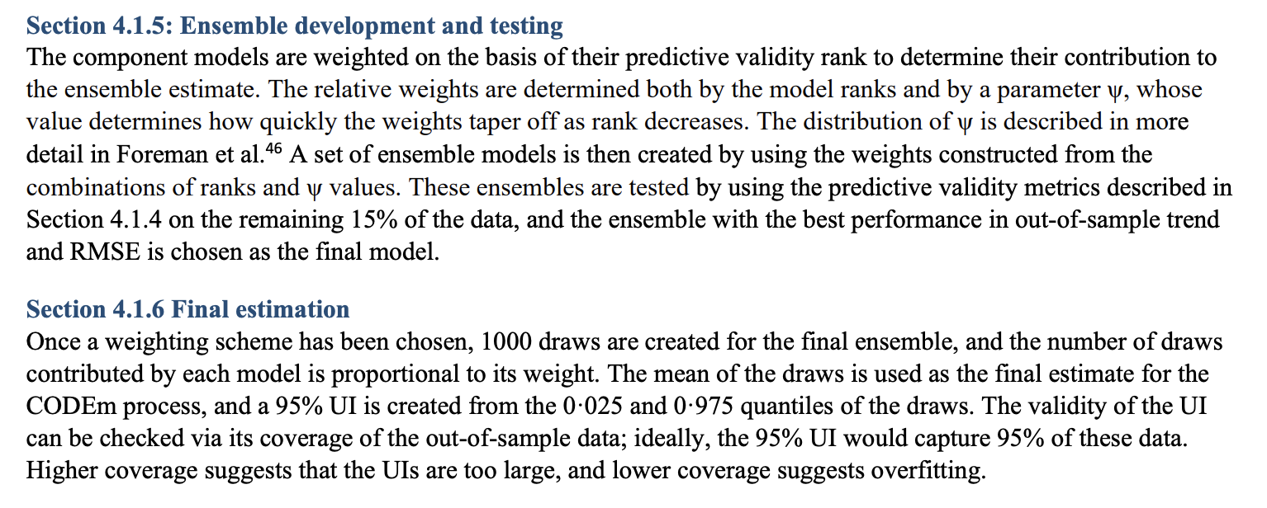

## ARIMA vs ML for Time Series Modelling

<https://www.mdpi.com/1999-5903/15/8/255>

focuses on recent studies (published post 2018), with two exceptions

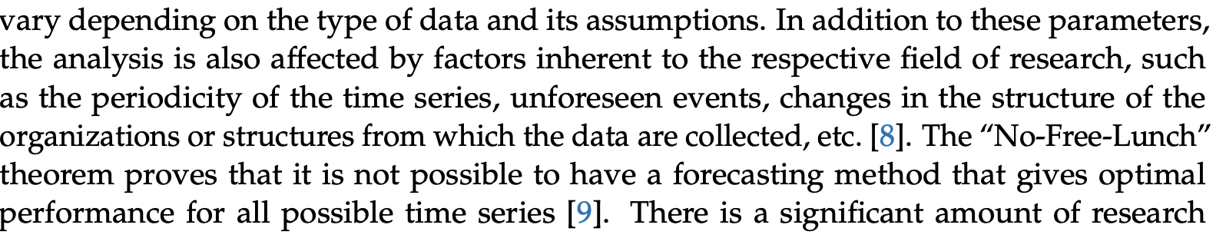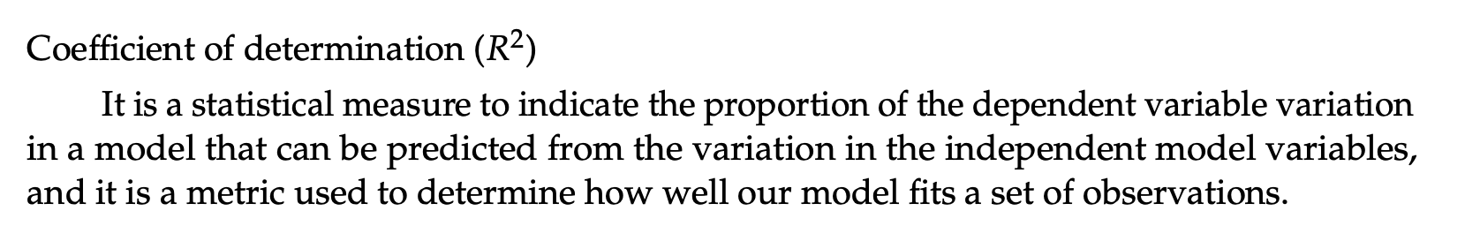 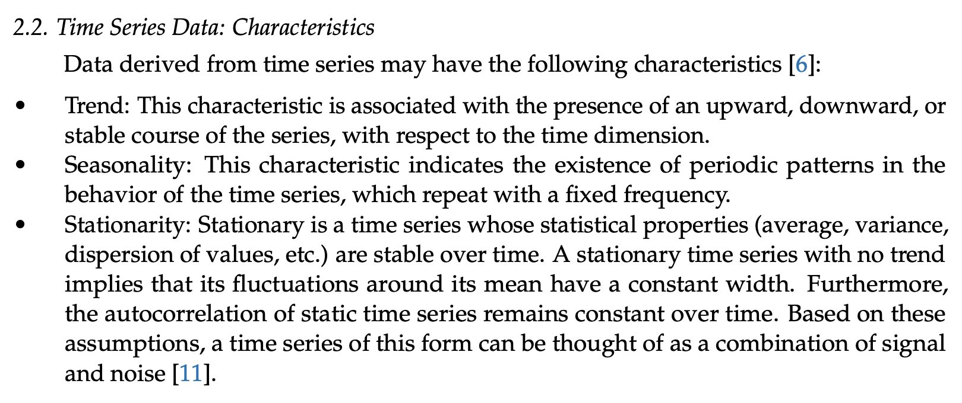 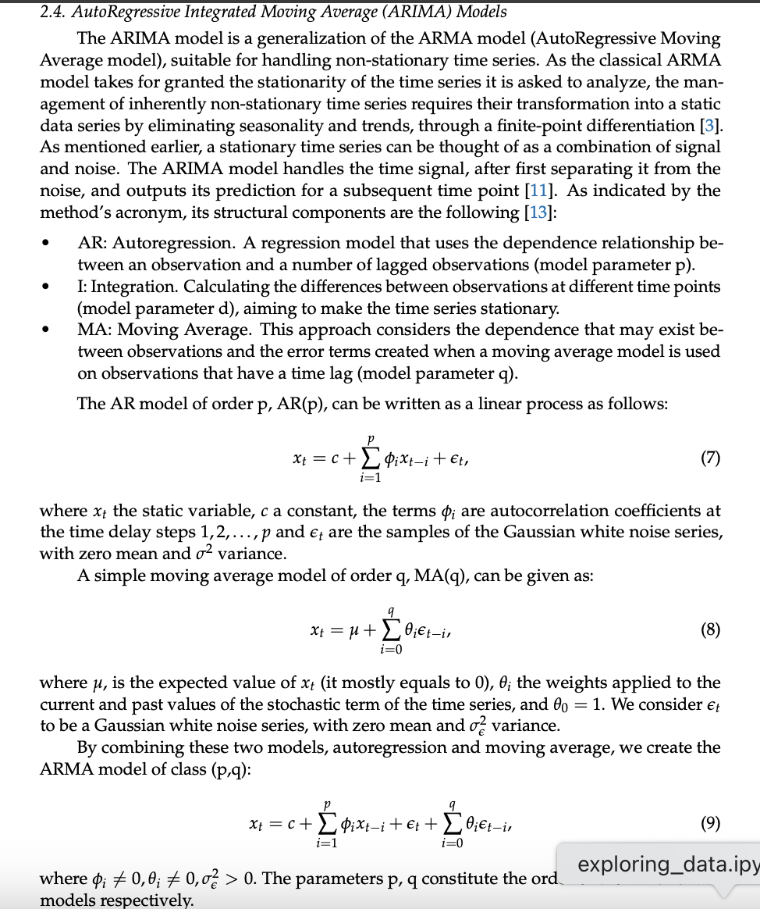 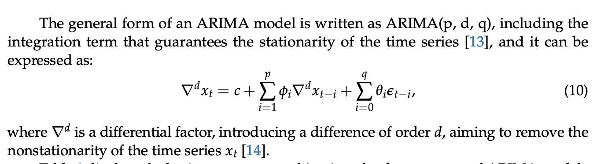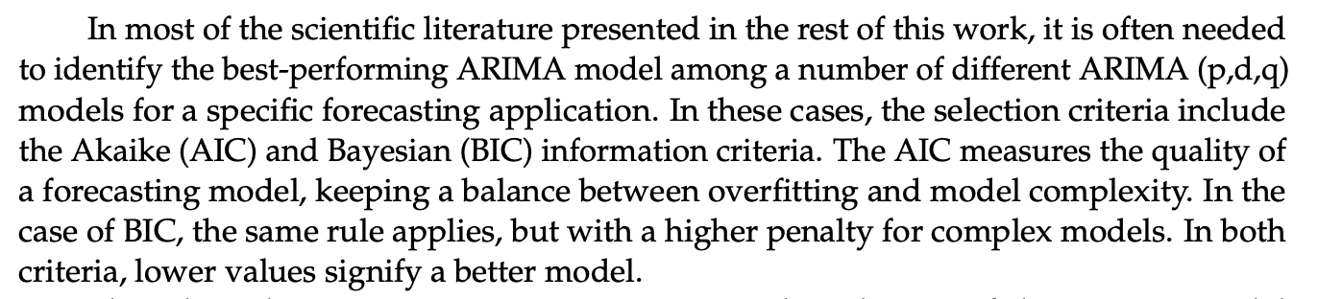 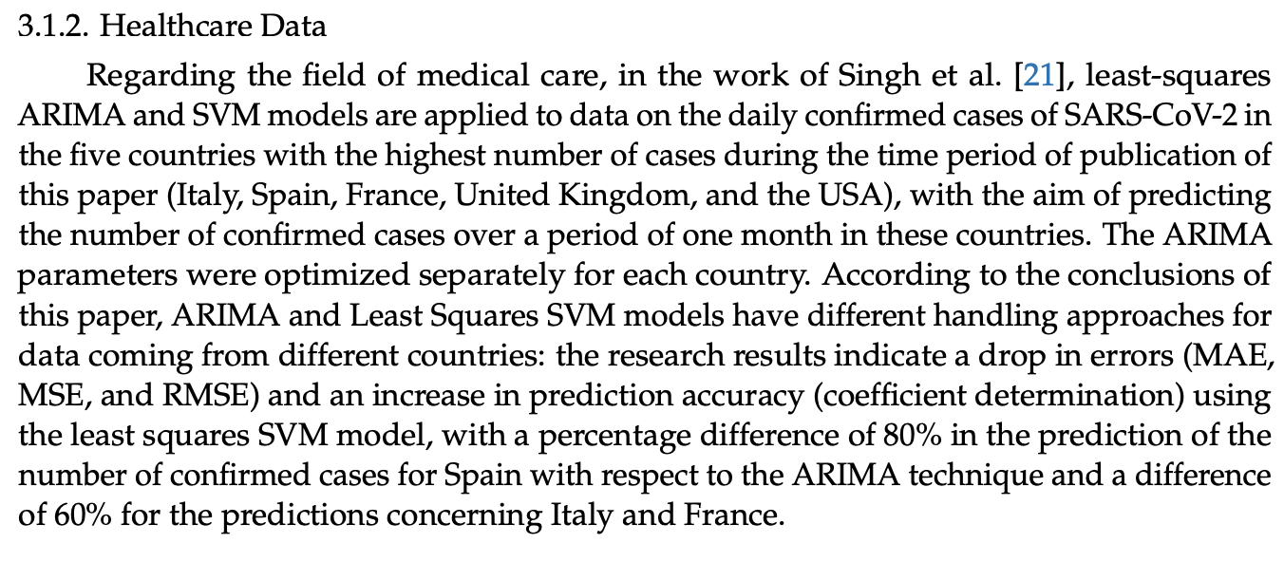 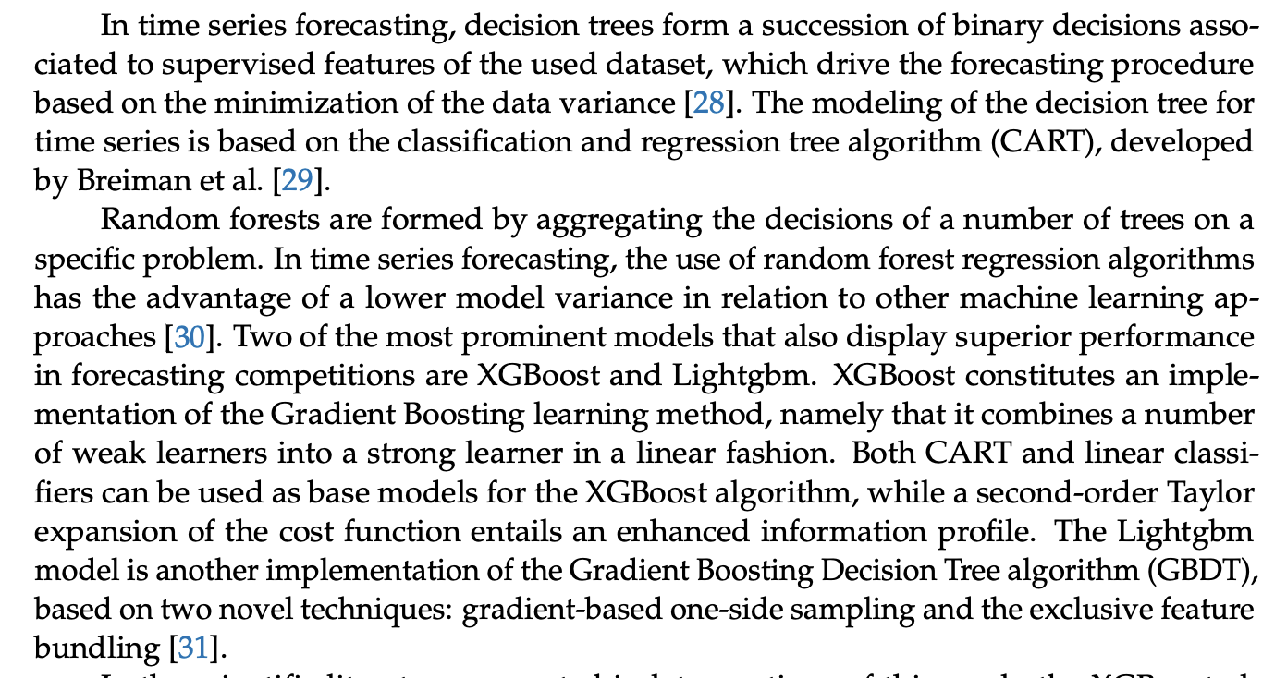 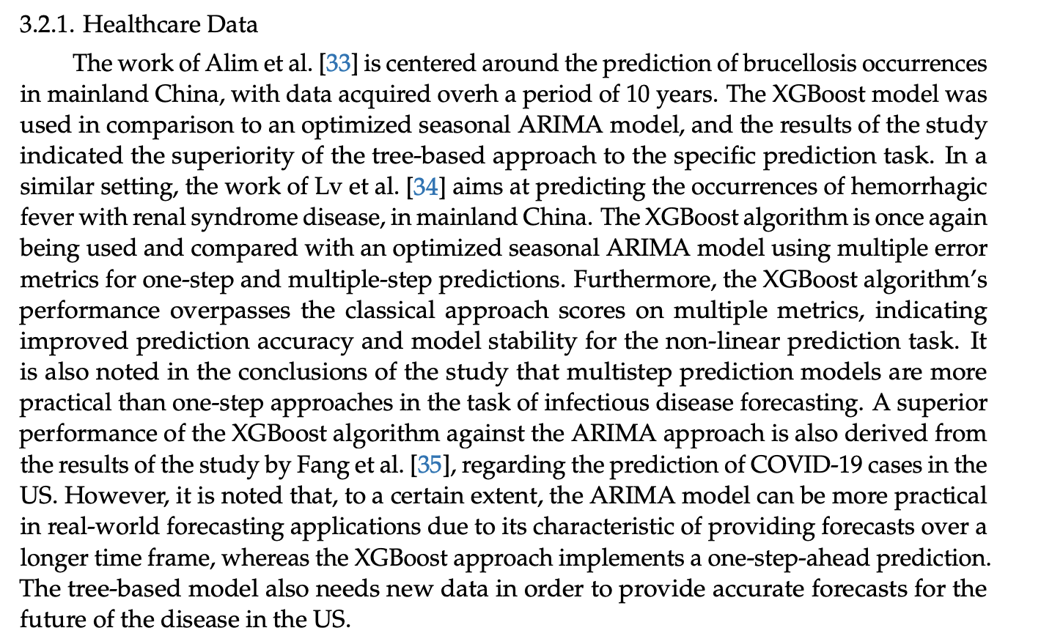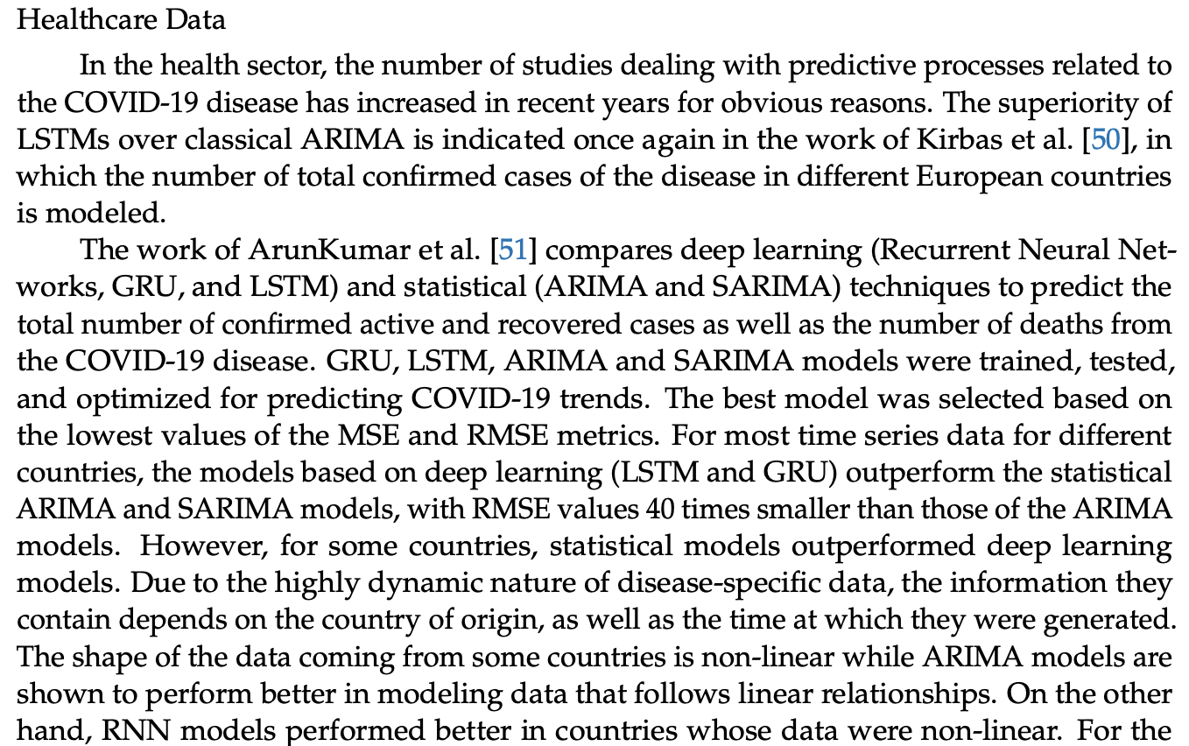

* Good discussion point

See paper for description of different deep learning models (e.g. MLP, RNN, LTSM)

* MMR is non-linear?
  + Check this and use it as justification for not choosing ARIMA

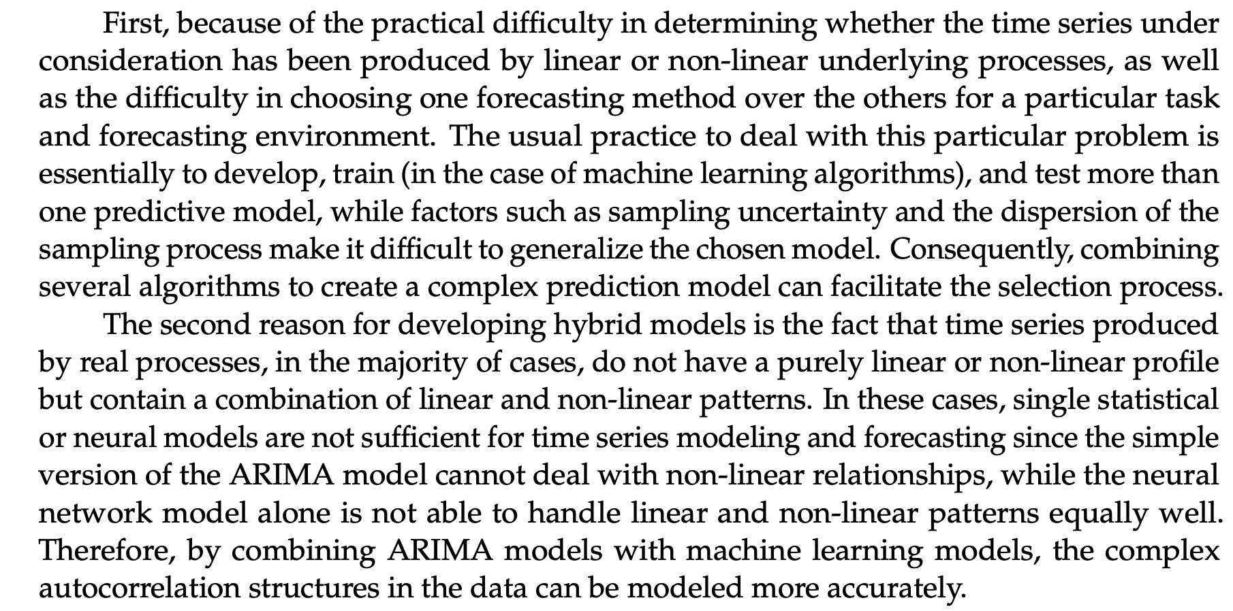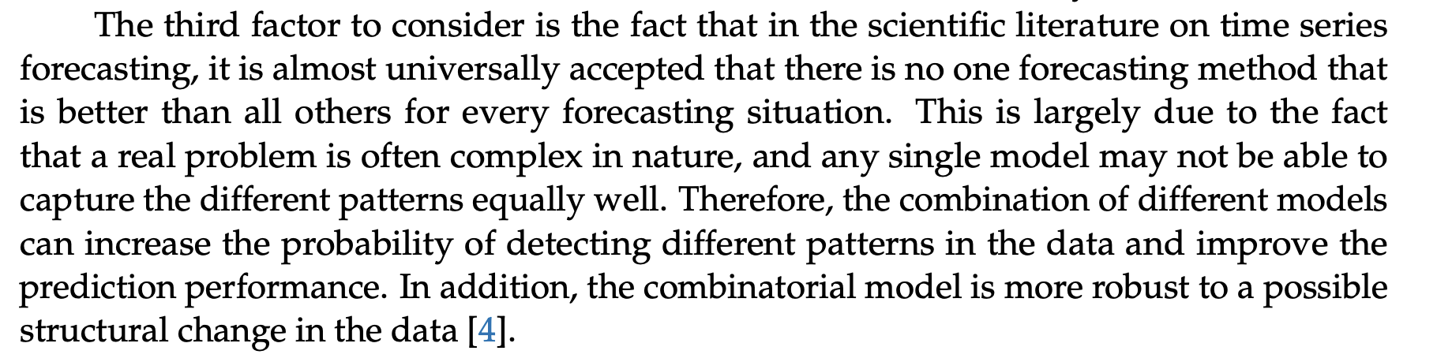

* Potential future direction?

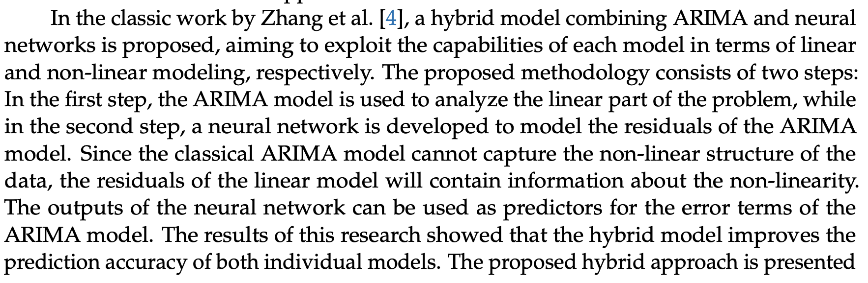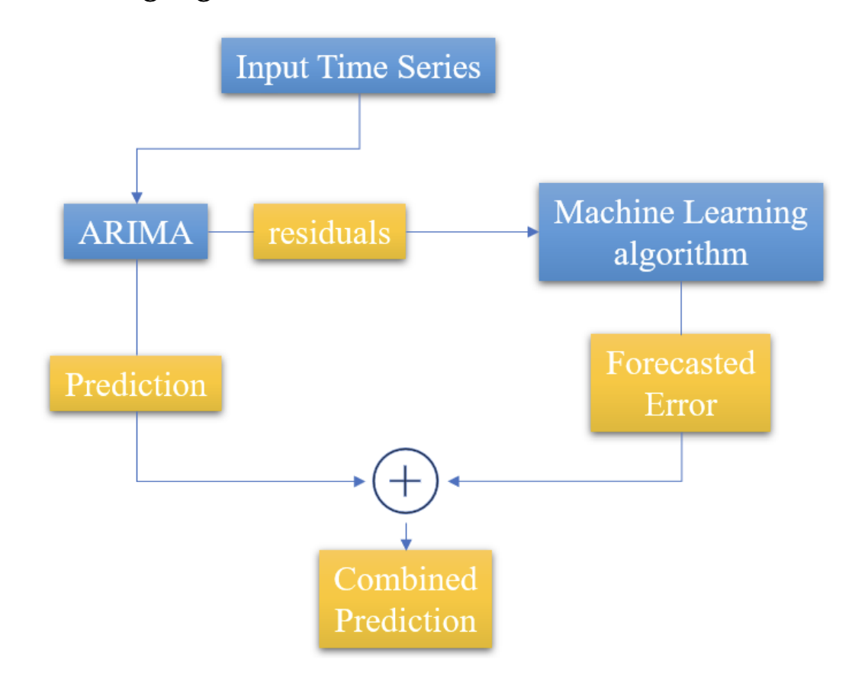

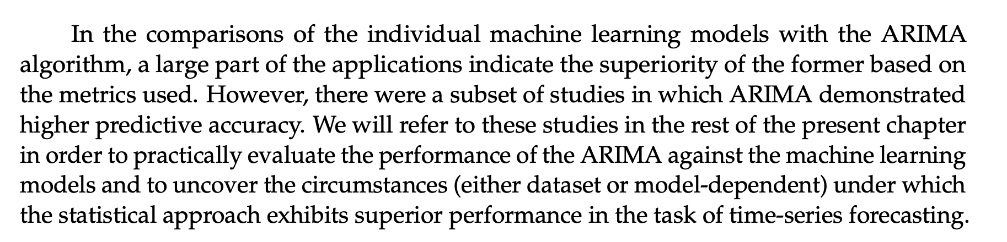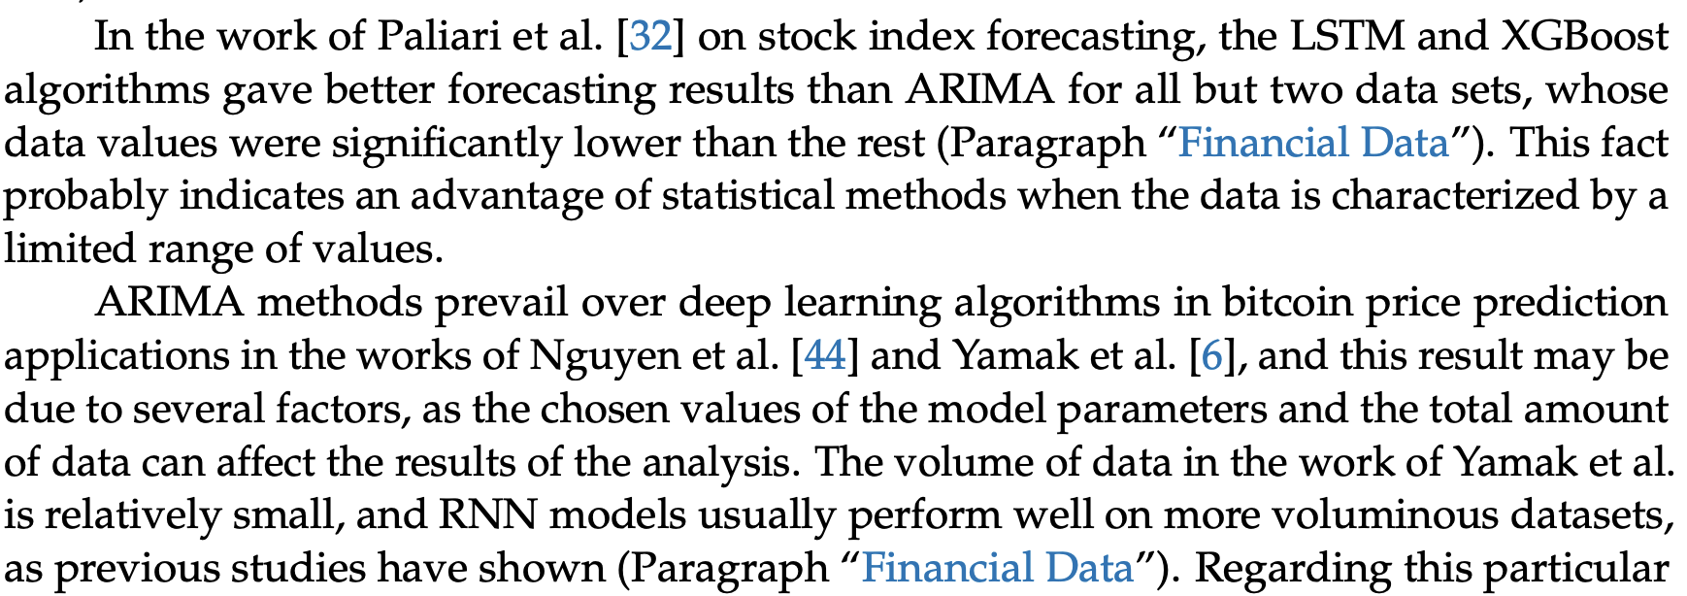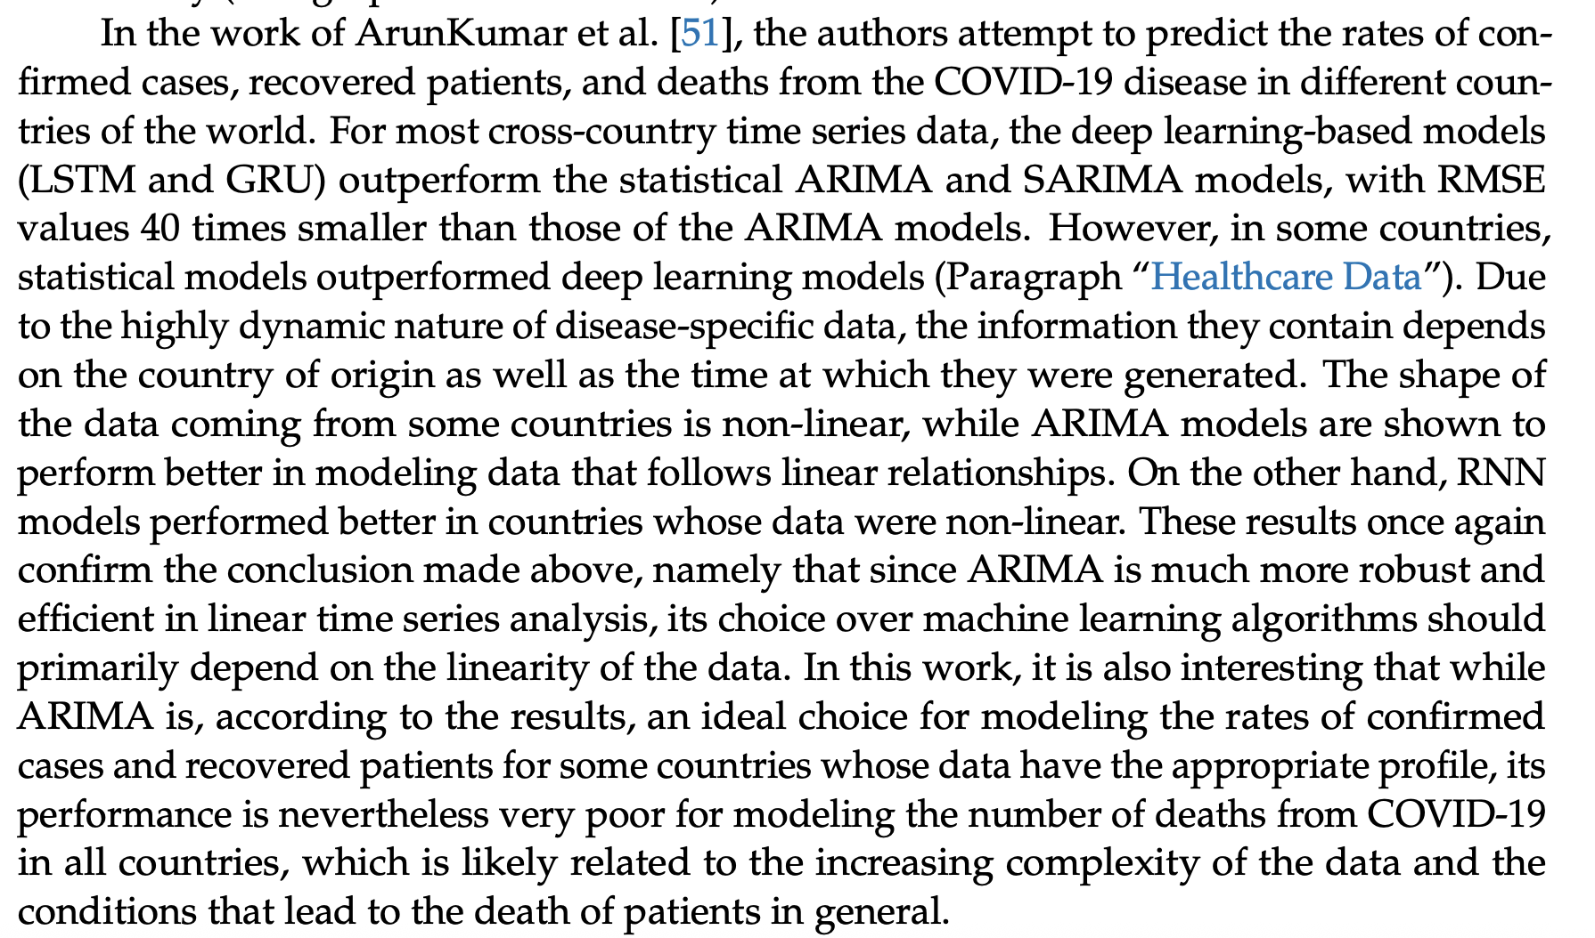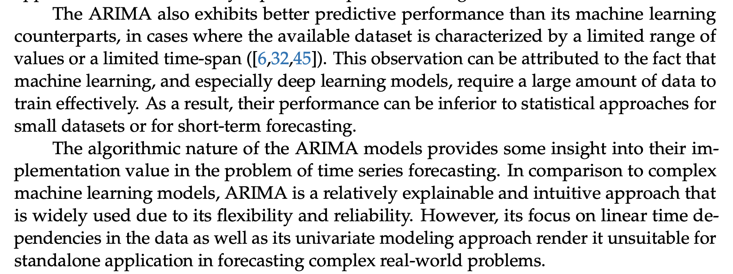

## WHO Modelling

Citation: Trends in maternal mortality estimates 2000 to 2023: estimates by WHO, UNICEF, UNFPA, World Bank Group and UNDESA/Population Division. Geneva: World Health Organization; 2025. Licence: CC BY-NC-SA 3.0 IGO

All text here is ‘copy pasted’

* Read more about the causes of maternal death in provided areas (this information was not put into this document to keep it focused).
* See references for this info
  + Cresswell JA, Alexander M, Chong MYC, Link HM, Pejchinovska M, Gazeley U et al. Global and regional causes of maternal deaths 2009-20: a WHO systematic analysis. Lancet Glob Health. 2025 (https://doi.org/10.1016/ s2214-109x(24)00560-6).
  + Ramson JA, Williams MJ, Afolabi BB, Colagiuri S, Finlayson KW, Hemmingsen B et al. Pregnancy, childbirth and the postpartum period: opportunities to improve lifetime outcomes for women with non-communicable diseases. Med J Aust. 2024;221(7):350-3 (https://doi.org/10.5694/mja2.52452).
  + Editorial: Non-communicable diseases in reproductive care. Lancet. 2024;404(10448):95 (https://doi. org/10.1016/S0140-6736(24)01298-4).
  + Souza JP, Day LT, Rezende-Gomes AC, Zhang J, Mori R, Baguiya A et al. A global analysis of the determinants of maternal health and transitions in maternal mortality. Lancet Glob Health. 2024;12(2):e306-e16 (https:// doi.org/10.1016/S2214-109X(23)00468-0).

See section 5 for discussion points of how the results can be applied and section 5.3.3 for importance of more data collection

* E.g. comparability difficulty
* E.g. loss of collection infrastructure due to emergencies
* Akselrod S, Banerjee A, Collins TE, Acharya S, Artykova N, Askew I et al. Integrating maternal, newborn, child health and non-communicable disease care in the sustainable development goal era. Front Public Health. 2023;11:1183712 (<https://doi.org/10.3389/fpubh.2023.1183712>).
* Souza JP, Day LT, Rezende-Gomes AC, Zhang J, Mori R, Baguiya A et al. A global analysis of the determinants of maternal health and transitions in maternal mortality. Lancet Glob Health. 2024;12(2):E306–16 (https://doi. org/10.1016/S2214-109X(23)00468-0).
* Petersen EE, Davis NL, Goodman D, Cox S, Syverson C, Seed K et al. Racial/Ethnic Disparities in Pregnancy Related Deaths - United States, 2007 -2016. MMWR Morb Mortal Wkly Rep. 2019;68(35):762-5 (https://doi. org/10.15585/mmwr.mm6835a3).
* Tunçalp Ö, Souza JP, Hindin MJ, Santos CA, Oliveira TH, Vogel JP et al. Education and severe maternal outcomes in developing countries: a multicountry cross-sectional survey. Bjog. 2014;121 Suppl 1:57-65 (https://doi.org/10.1111/1471-0528.12634).
* Govender V, Topp SM, Tunçalp Ö. Rethinking trust in the context of mistreatment of women during childbirth: a neglected focus. BMJ Glob Health. 2022;7(5):e009490 (<https://doi.org/10.1136/bmjgh-2022-009490>).
* Zampas C, Amin A, O'Hanlon L, Bjerregaard A, Mehrtash H, Khosla R et al. Operationalizing a Human Rights-Based Approach to Address Mistreatment against Women during Childbirth. Health Hum Rights. 2020;22(1):251-64 (https://pmc.ncbi.nlm.nih.gov/articles/PMC7348458/). 19. Bohren MA, Iyer A, Barros AJD, Williams CR, Hazfiarini A, Arroyave L et al. Towards a better tomorrow: addressing intersectional gender power relations to eradicate inequities in maternal health. EClinicalMedicine. 2024;67:102180 (<https://doi.org/10.1016/j.eclinm.2023.102180>).
* Koblinsky M, Moyer CA, Calvert C, Campbell J, Campbell OM, Feigl AB et al. Quality maternity care for every woman, everywhere: a call to action. Lancet. 2016;388(10057):2307-20 (https://doi.org/10.1016/s0140- 6736(16)31333-2).
* Conway F, Portela A, Filippi V, Chou D, Kovats S. Climate change, air pollution and maternal and newborn health: An overview of reviews of health outcomes. J Glob Health. 2024;14:04128 (https://doi.org/10.7189/ jogh.14.04128)
* Roos N, Kovats S, Hajat S, Filippi V, Chersich M, Luchters S et al. Maternal and newborn health risks of climate change: A call for awareness and global action. Acta Obstet Gynecol Scand. 2021;100(4):566-70 (https://doi. org/10.1111/aogs.14124).

Importance of tracking late maternal deaths

* Not included in mmr numerator for international comparability

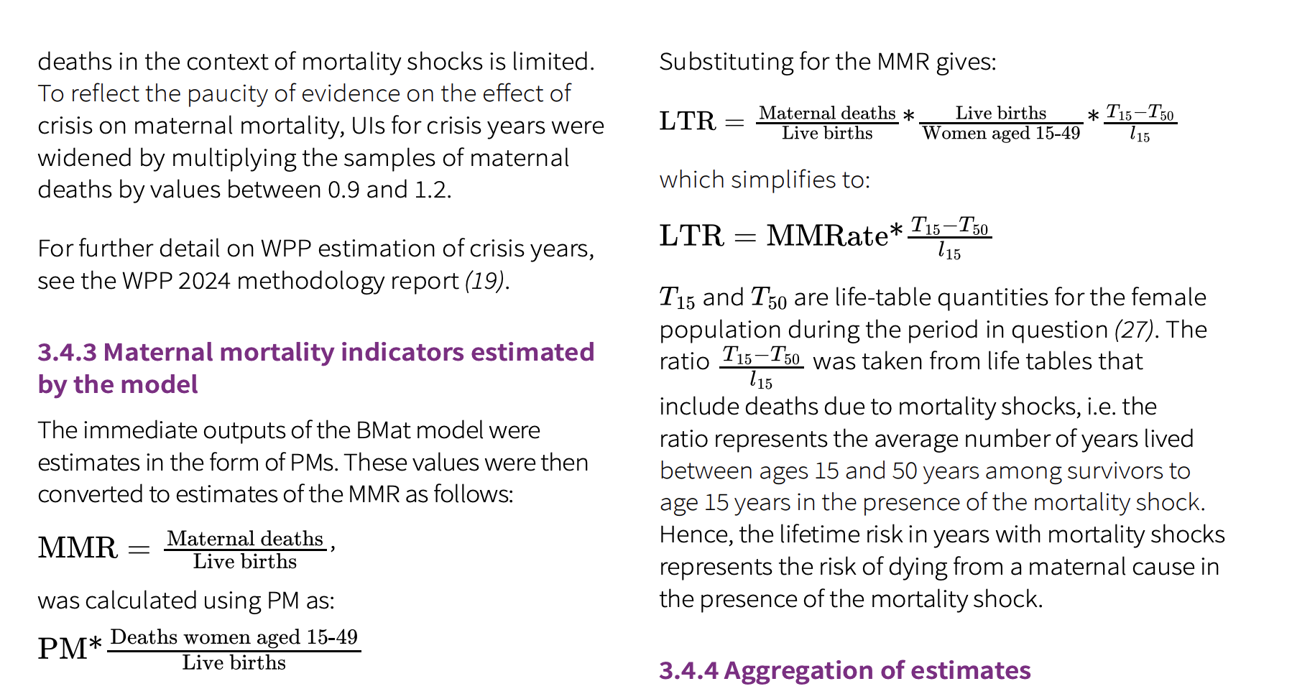

* Use the above to show why lifetime risk was excluded (mmr used to calculate it)
* Wilmoth J. The lifetime risk of maternal mortality: concept and measurement. Bull World Health Organ. 2009;87(4):256-62 (https://doi.org/10.2471/blt.07.048280).

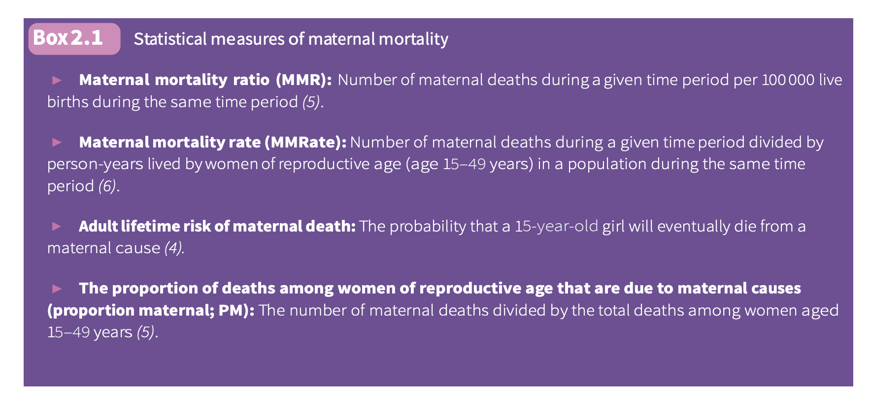

* Wilmoth JR, Mizoguchi N, Oestergaard MZ, Say L, Mathers CD, Zureick-Brown S et al. A new method for deriving global estimates of maternal mortality. Stat Politics Policy. 2012;3(2):2151-7509.1038 (https://doi. org/10.1515/2151-7509.1038).

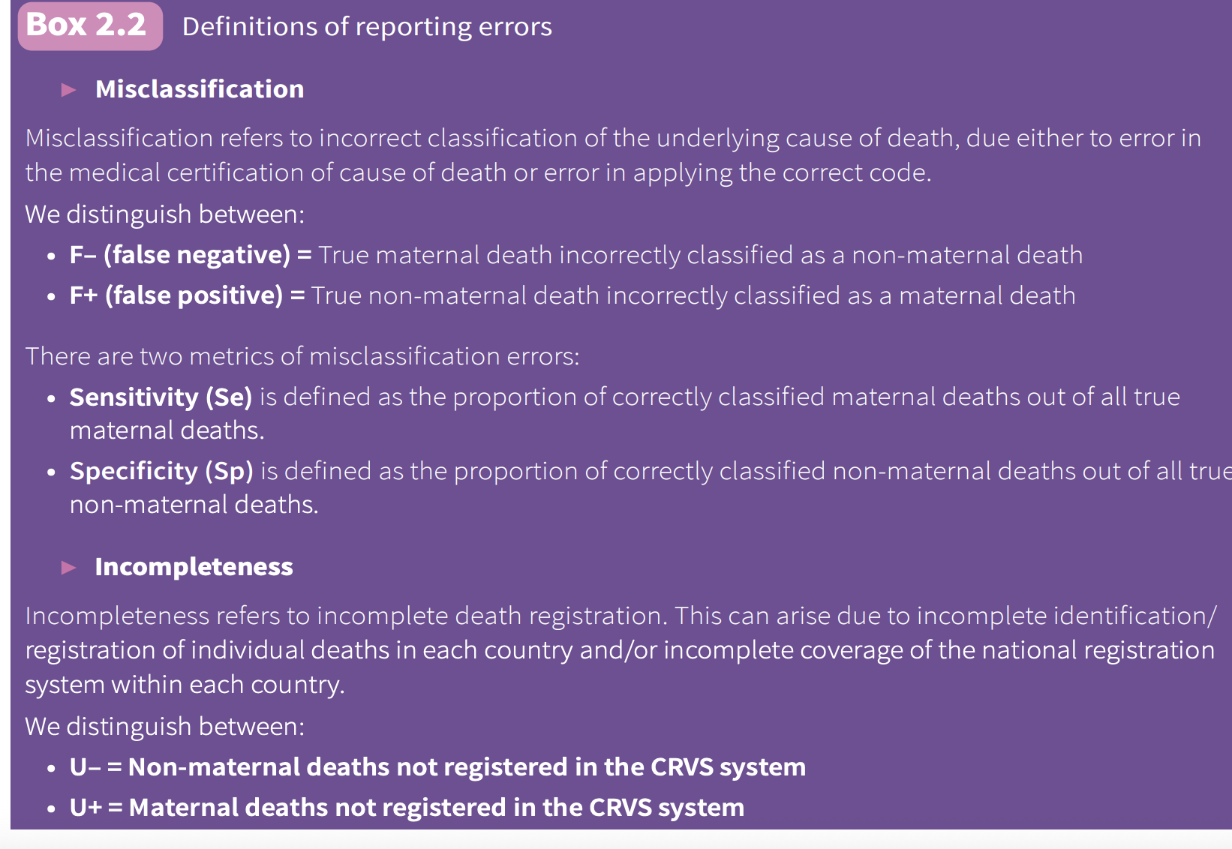

e.g. the following could be used to help justify use of so many variables

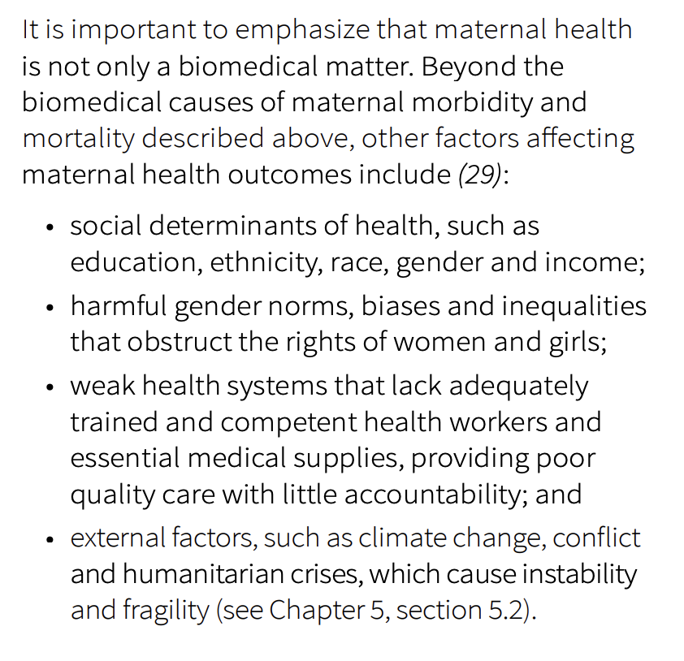

‘in 2023, for the first time, no countries fell into the extremely high maternal mortality category (defined as over 1000 maternal deaths per 100 000 live births). Additionally, more than one-third of countries surveyed have very low maternal mortality’

* See forward in this document for brief overview of life-saving technologies and countries that have made progress

‘At the Seventy-seventh World Health Assembly in May 2024, a resolution was passed to Accelerate progress towards reducing maternal, newborn and child mortality in order to achieve Sustainable Development Goal targets 3.1 and 3.2, in light of concerns that progress to advance the SDG agenda had stalled.’

‘The United Nations Maternal Mortality Estimation Inter-Agency Group (MMEIG) – comprising WHO, the United Nations Agency for Children (UNICEF), the United Nations Population Fund (UNFPA), the World Bank Group and the United Nations Department of Economic and Social Affairs, Population Division (UNDESA/Population Division) – was established in 2006 to harmonize and improve estimation and modelling methods across United Nations agencies. The MMEIG collaborated with technical experts via its Advisory Group to develop this new round of global-, regional- and country-level maternal mortality estimates for the period 2000–2023. The Technical Advisory Group (TAG) on Maternal Mortality and Maternal Cause of Death Estimation – composed of demographers, epidemiologists and statisticians from different world regions – provided technical advice (15). The estimates for 2000–2023 presented in this report are the 11th in a series of analyses by WHO, UNICEF and other United Nations partner agencies to examine global, regional and country progress in reducing maternal mortality’

* ‘the work of the MMEIG includes direct engagement with Member States as a fundamental and integral part of the estimation process’

‘This report presents internationally comparable global-, regional- and country-level estimates and trends for maternal mortality between 2000 and 2023. A total of 195 countries and territories met the criteria to be included the data analyses and in the results presented in this report’

Modelling process:

‘Previously, the United Nations Maternal Mortality Estimation Inter-Agency Group (MMEIG) have published reports on maternal mortality trends (including estimates up to 2005, 2008, 2010, 2013, 2015, 2017 and 2020) presenting estimates developed with independent advice from the technical advisory group (TAG) of external academic experts (1-7). The methods described here for developing estimates of levels and trends of maternal mortality between 2000 and 2023 build upon the methods used in those previous round’

‘The MMEIG Bayesian maternal mortality misclassification (BMis) model for CRVS adjustment and the MMEIG Bayesian maternal mortality estimation (BMat) model (described in sections 3.4.1 and 3.4.2, respectively) together provide the most upto-date maternal mortality estimates for the 2000– 2023 timespan.’

‘In previous estimates, the MMEIG only included countries and territories with a population greater than 100 000. This restriction was removed for the current round of estimates, such that this report presents estimates for 195 countries and territories where at least one female death from any cause (aged 15–49) is estimated for each year across the period 1985–2023 by the UNDESA/Population Division’s World population prospects 2024 (WPP 2024). R’

Data inputs to the model:

The gdp, fertility and skilled birth were obtained from consultation with other agencies

* Civil registration and vital statistics (CRVS)
  + A CRVS system is a national system that involves the routine registration of births and deaths, and the compilation of vital statistics. Civil registration is defined by the United Nations as: “the continuous, permanent, compulsory, and universal recording of the occurrence and characteristics of vital events and other civil status events pertaining to the population as provided by decree, law or regulation, in accordance with the legal requirements in each country” (11). For the purposes of the MMEIG maternal mortality ratio (MMR) estimates,17 the CRVS data are operationally defined as the data reported to the WHO Mortality Database (12). The WHO Mortality Database is a compilation of mortality data as reported annually by Member States from their civil registration systems to WHO. Data are provided disaggregated by sex, age group and cause of death. Only medically certified deaths are included; underlying cause of death is reported in accordance with the appropriate International statistical classification of diseases and related health problems (ICD) rules and classification (13).
* Specialised studies on maternal mortality
  + Specialized studies on maternal mortality generally triangulate information from multiple sources, including, but not limited to, medical records, police records, surveillance systems, national registries, death certificates, censuses, medical autopsies and administrative reviews to estimate the true number of maternal deaths in a specified geographic area. The design of, and the information provided by, specialized studies vary substantially. Two of the more common examples of specialized studies on maternal mortality are:
    - confidential enquiries into maternal deaths (CEMD) – “a systematic multidisciplinary anonymous investigation of all or a representative sample of maternal deaths occurring at an area, regional (state) or national level which identifies the numbers, causes and avoidable or remediable factors associated with them” (14);
    - reproductive-age mortality studies (RAMOS), which involve first identifying and then investigating and establishing the causes of all deaths of women of reproductive age in a defined population using multiple sources of data (15).
* Surveys, censuses, and other miscellaneous data sources for maternal mortality
  + The MMEIG also use population-based household surveys including the Demographic and Health Surveys (DHS) and the Multiple Indicator Cluster Surveys (MICS), which use the sisterhood method (15, 16) to identify deaths of women of reproductive age and their causes. Additionally, national censuses that collect information on pregnancy related and/or maternal deaths are included.
* Other data sources
  + national-level surveillance data from the country’s ministry of health or national statistics office
  + The MMEIG maternal mortality estimates use data from multiple United Nations agencies, either for the calculation of the MMR (sections 3.2.1–3.2.3) or as covariates in the mode
    - For all-cause deaths to women aged 15–49, the UNDESA/Population Division’s WPP 2024 was used
    - The MMEIG used estimates of deaths due to HIV from the Joint United Nations Programme on HIV/AIDS (UNAIDS) for countries for which UNAIDS publishes such estimates
    - ‘live births data’: Live births were taken from WPP 2024 . Bayesian hierarchical models were used to estimate the annual time series of total fertility and age-specific fertility rates from 1950 to 2024 for all countries. These models incorporated available empirical evidence from vital statistics, population censuses and population-based household surveys
    - Predictor variables in the maternal mortality model
      * Gross domestic product (GDP) per capita is expressed in constant prices with the reference year 2021 and converted by purchasing power parity (PPP) to international dollars. GDP data from the World Bank Group were used for each country (21), and in instances they were supplemented by unofficial estimates derived by the MMEIG using growth rates in previous MMEIG GDP estimates and/or models.
      * General fertility rate (GFR) was computed using data on live births and population size (number of women aged 15–49) from WPP 2024 (18).
      * Skilled birth attendant (SBA) data consist of time series derived using all available data from population-based national household survey data and countries’ routine reporting mechanisms (WHO and UNICEF Joint Skilled Birth Attendant database (22)).
* All observed mortality inputs are subject to random error. The random error may include sampling error (where obtained from surveys), stochastic error (where from a small number of deaths) or nonsampling error (i.e. random errors that may occur at any point during the data-collection process). The MMEIG calculated error variances to account for these errors. Observations with smaller error variances indicate less uncertainty and hence carry a greater weight in determining estimates than observations with large error variances.

Data Pre-Processing

An upward adjustment of 10% was applied to all observations that were not obtained from CRVS or specialized studies, to account for deaths early in pregnancy that might not have been captured.

These models are broken down into global and “one-country” implementations. Model assumptions are the same for global and one-country models. To estimate the MMR, first the BMis global model is used to obtain the fixed non-population-specific CRVS sensitivity and specificity parameters. Secondly, multiple instances of the BMis one-country model are used to obtain adjustment factors for each countryyear of interest. The adjustment factors obtained from the BMis global model and one-country runs are then applied in the BMat global and BMat one-country models. In the next phase, the BMat global model is used to obtain the fixed non-population-specific BMat parameters. Subsequently, for each country, a one-country BMat model (using the default model set-up) was conducted using data for the non-COVID years in order to obtain the country-level estimates for non-COVID years

BMis Model:

* For countries with eligible CRVS data (see section 3.1.2), the BMis model is used to account for errors in reporting of maternal death in the CRVS to obtain the BMis adjustment factors.
* Relying on maternal deaths as reported in the CRVS system means there is a potential for error due to unregistered maternal deaths and/or misclassification of the cause of death within the CRVS system (see section 2.3 for definitions of reporting errors). The BMis model produces adjustment factors derived from sensitivity and specificity estimates for all countryyears of CRVS data, before the data are included in the BMat model
* obtained by fitting the model to the global database of all specialized studies within the CRVS
* Country-estimates for sensitivity (Se) and specificity (Sp) are obtained in country-specific runs. For a country with specialized studies within the CRVS, the model is fitted to all available data. However, it is rare that a country has data from specialized studies within the CRVS for the entire estimation period. In such instances, Se and Sp values for the years before the earliest observation reference year of a specialized study are modelled to converge backwards to the global Se and Sp estimates within a five-year period. For years after the latest study observation reference year, the point estimates of Se and Sp are kept constant up to the end of the estimation period. For countries without specialized studies within the CRVS, Se and Sp are set to be equivalent to the global estimates.

BMat Model:

* For all countries, the BMat model is used to estimate the MMR for each country-year of interest.
* Estimation and projection of maternal mortality indicators was undertaken using the BMat model. This model is intended to ensure that the MMR estimation approach is consistent across all countries but remains flexible in that it:
  + is based on covariate-driven trends to inform estimates in countries or country-periods with limited information;
  + captures observed trends in countries with longer time series of observations;
  + takes into account the differences in stochastic and sampling errors across observations.
* In the BMat model, the MMR for each country-year is modelled as the sum of the HIV MMR (i.e. the portion of MMR that is due to HIV-related maternal deaths) and the non-HIV MMR (i.e. the portion of MMR that is due to non-HIV-related maternal deaths): MMR = non-HIV MMR + HIV MMR, where non-HIV-related maternal deaths refer to maternal deaths due to direct obstetric causes or to indirect causes other than HIV/AIDS, while HIVrelated maternal deaths are those maternal deaths to women with HIV/AIDS caused by the aggravating effects of pregnancy on HIV/AIDS.
* The BMat model was fitted to all data available in the country (see Box 3.1), once adjustments had been made and uncertainty associated with the data points had been incorporated (see section 3.1.4). Observations with smaller error variances are more informative of the true PM and will thus carry a greater weight in determining the estimates as compared with observations with larger error variances.
* In countries with high-quality data with little uncertainty, the final BMat estimates closely track the country data and have narrow uncertainty intervals (UIs). However, in the absence of data, or when data are very uncertain, the predictor variables (covariates) play an important role and inform the estimated trend in MMR.
* Estimation of expected non-HIV-related maternal deaths
  + A hierarchical regression model was used to obtain the expected number of non-HIV-related maternal deaths for each country-year, and the associated non-HIV MMR. The model predicts the proportion of deaths to women of reproductive age that are due to maternal causes (PM) using three predictor variables: the GDP per capita, the GFR and the presence of a skilled birth attendant (SBA) as a proportion of live births. These specific predictor variables were chosen from a broader list of potential predictor variables, which fell into three groups: indicators of social and economic development (e.g. GDP, human development index, life expectancy), process variables (e.g. SBA coverage, antenatal care, proportion of institutional births) and risk exposure variables (i.e. fertility level).
* Estimation of HIV-related indirect maternal deaths
  + 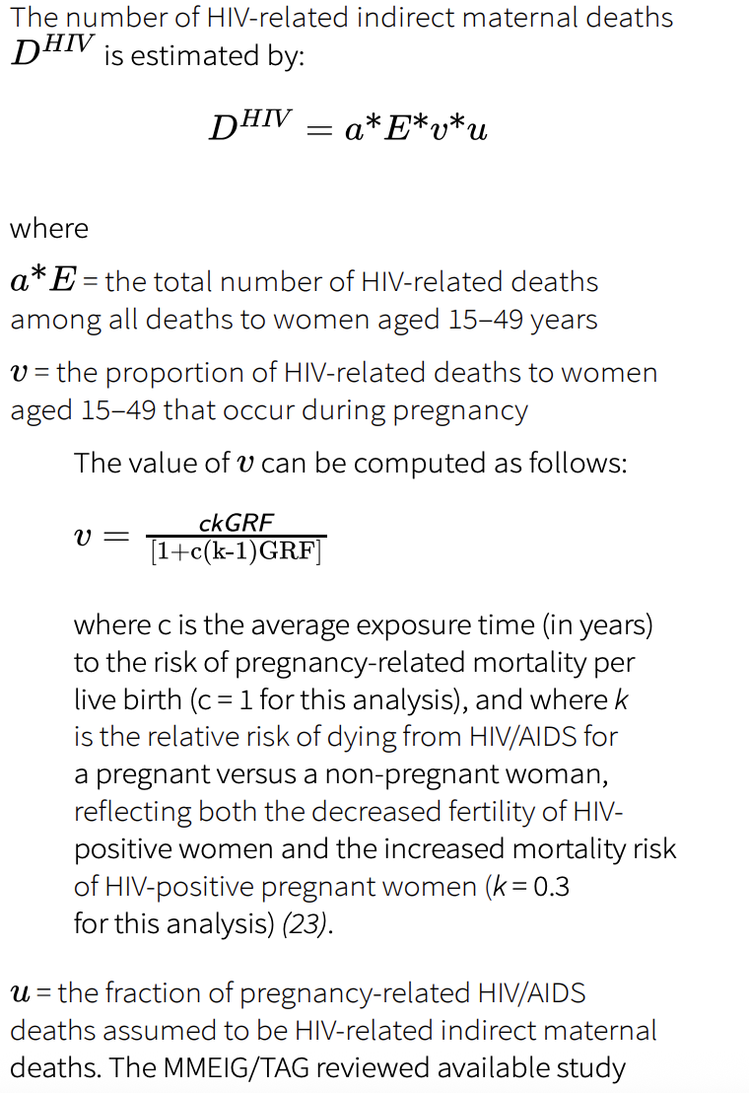

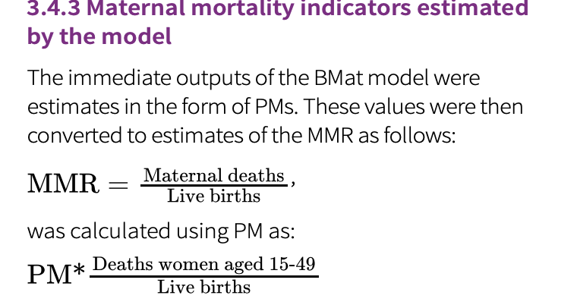

References:

* Alkema L, Zhang S, Chou D, Gemmill A, Moller A-B, Fat D et al. A Bayesian approach to the global estimation of maternal mortality. The Annals of Applied Statistics. 2017;11(3):1245-74 (https://doi.org/10.1214/16-AOAS1014).
* Wilmoth JR, Mizoguchi N, Oestergaard MZ, Say L, Mathers CD, Zureick-Brown S et al. A new method for deriving global estimates of maternal mortality. Stat Politics Policy. 2012;3(2):2151-7509.1038 (https://doi. org/10.1515/2151-7509.1038).
* Peterson E, Chou D, Moller AB, Gemmill A, Say L, Alkema L. Estimating misclassification errors in the reporting of maternal mortality in national civil registration vital statistics systems: a Bayesian hierarchical bivariate random walk model to estimate sensitivity and specificity for multiple countries and years with missing data. Stat Med. 2022;41(14):2483-96 (<https://doi.org/10.1002/sim.9335>)
* Zaba B, Calvert C, Marston M, Isingo R, Nakiyingi-Miiro J, Lutalo T et al. Effect of HIV infection on pregnancy related mortality in sub-Saharan Africa: secondary analyses of pooled community-based data from the network for Analysing Longitudinal Population-based HIV/AIDS data on Africa (ALPHA). Lancet. 2013;381(9879):1763-71 (https://doi.org/10.1016/s0140-6736(13)60803-x).
* Arab K, Spence AR, Czuzoj-Shulman N, Abenhaim HA. Pregnancy outcomes in HIV-positive women: a retrospective cohort study. Arch Gynecol Obstet. 2017;295(3):599-606 (https://doi.org/10.1007/s00404-016- 4271-y).

## A New Method for Deriving Global Estimates of Maternal Mortality

<https://pmc.ncbi.nlm.nih.gov/articles/PMC3886639/>

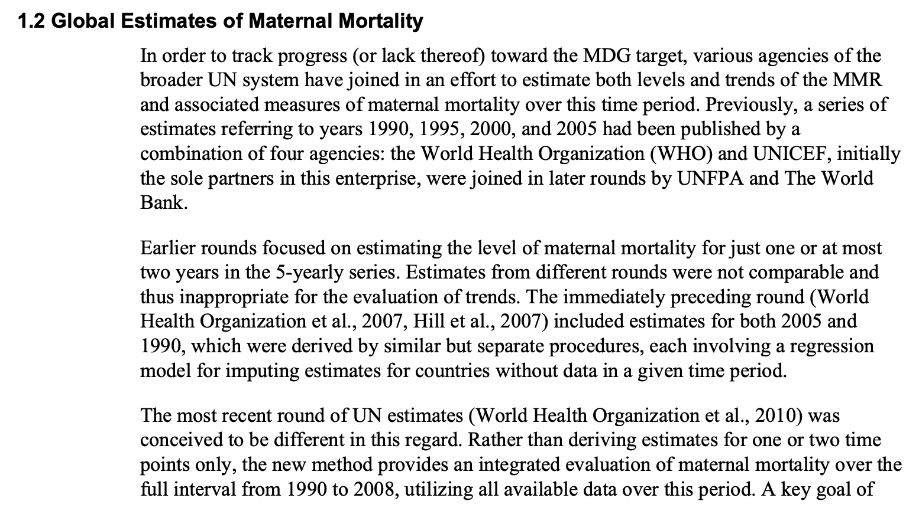

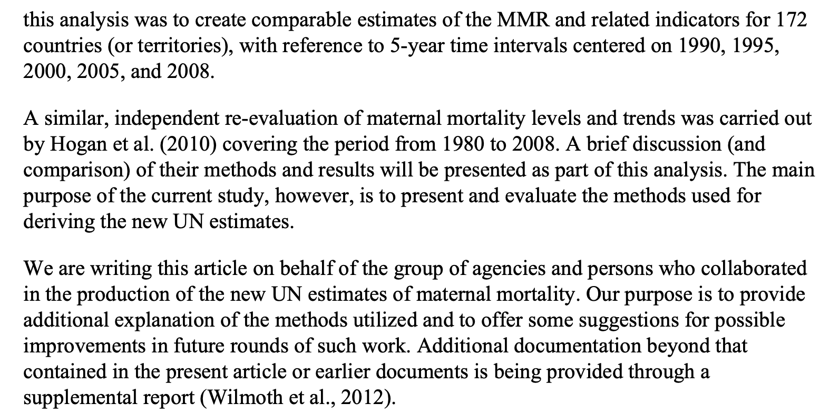 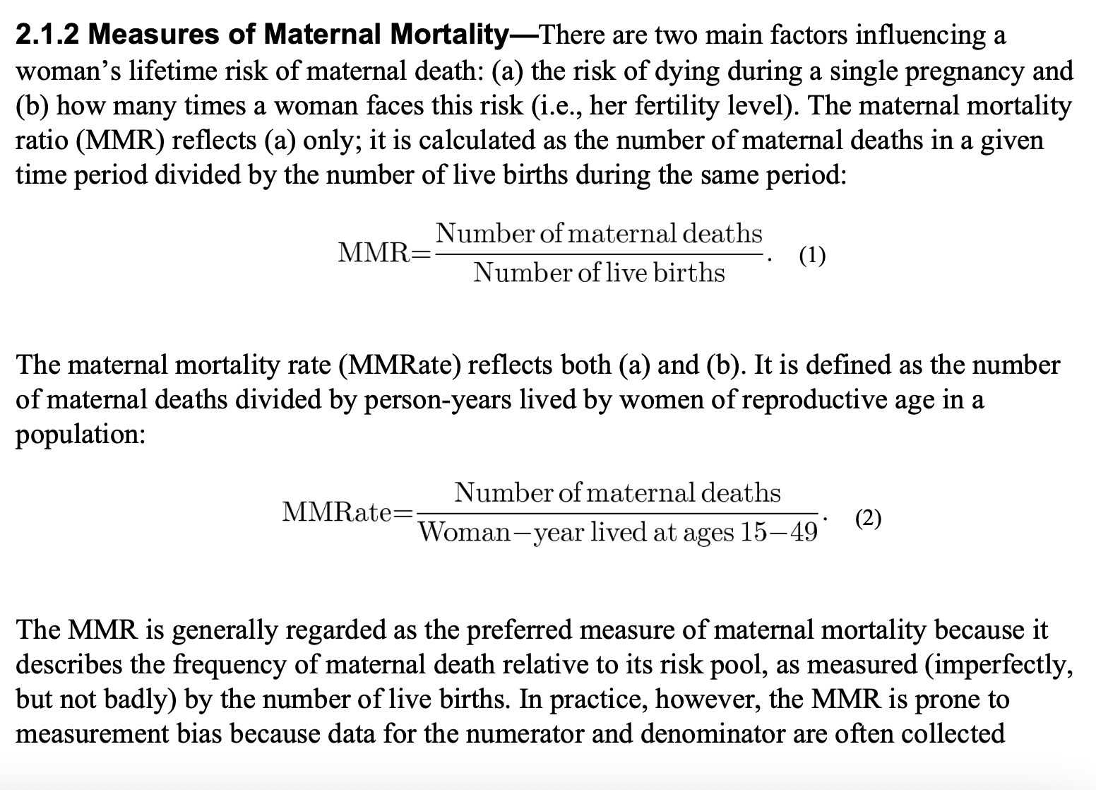

Through different means

* This paper contains the justification for use of PM in calculation of MMR as opposed to the above formulas

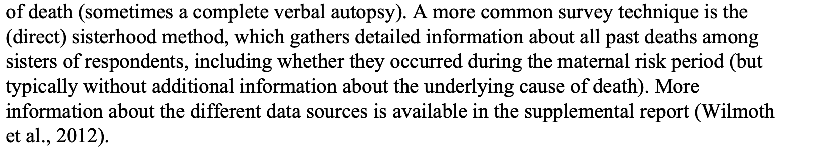

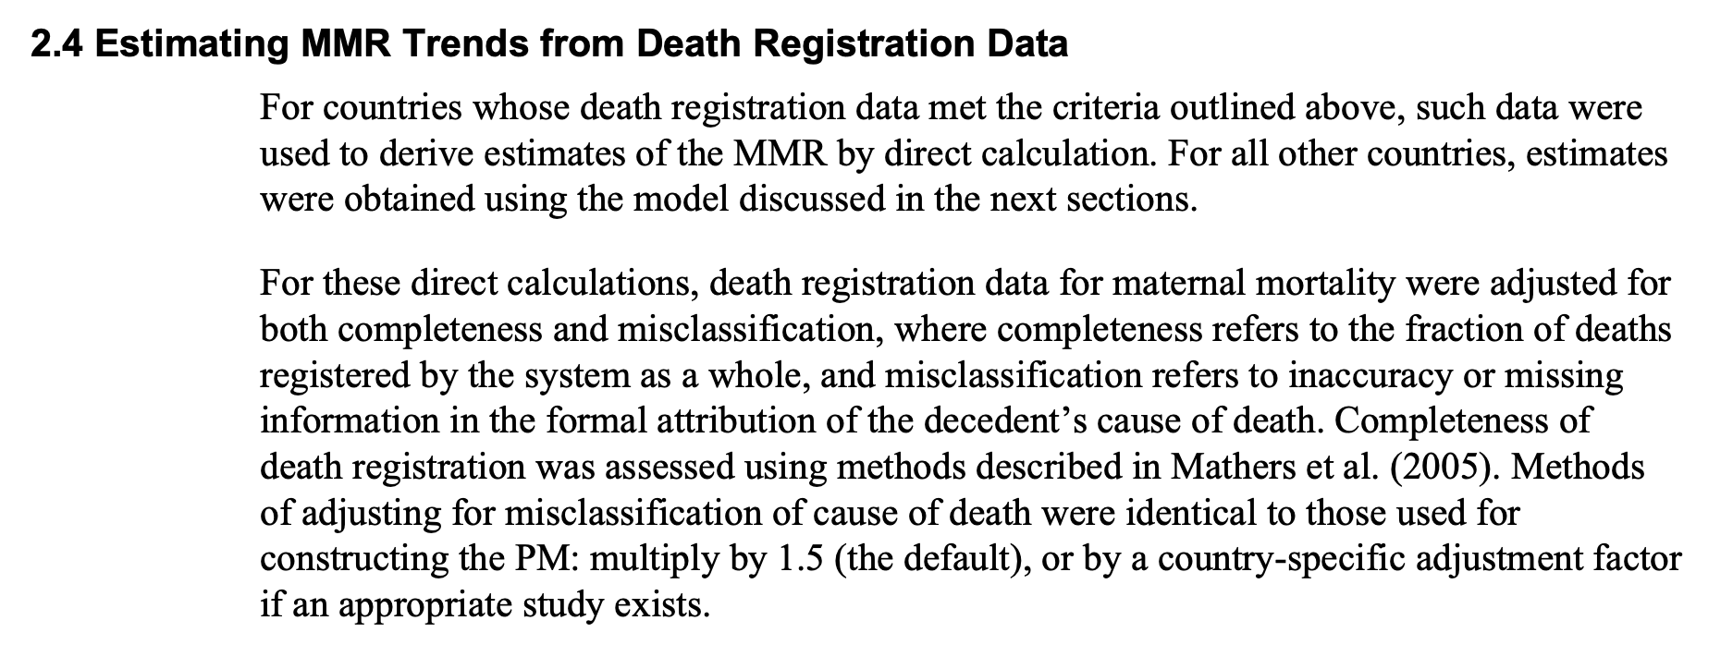 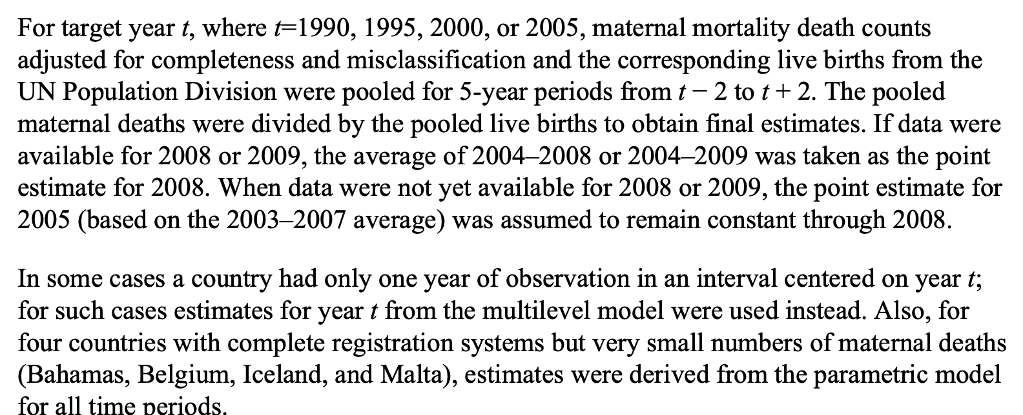

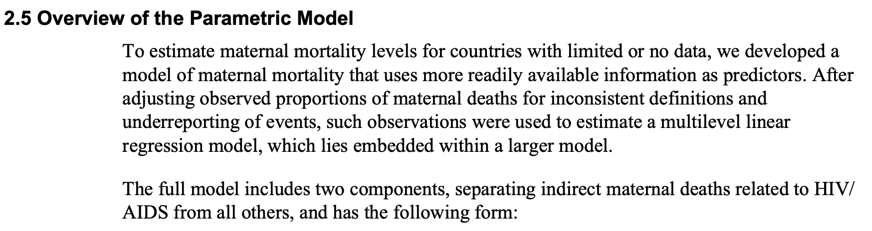

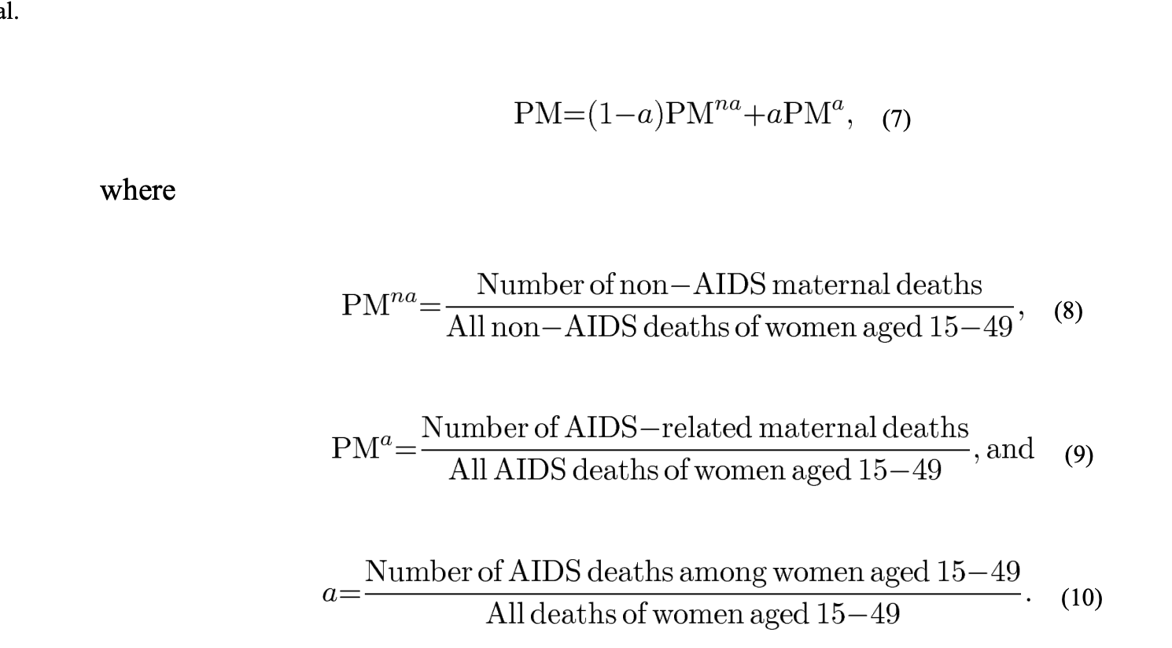 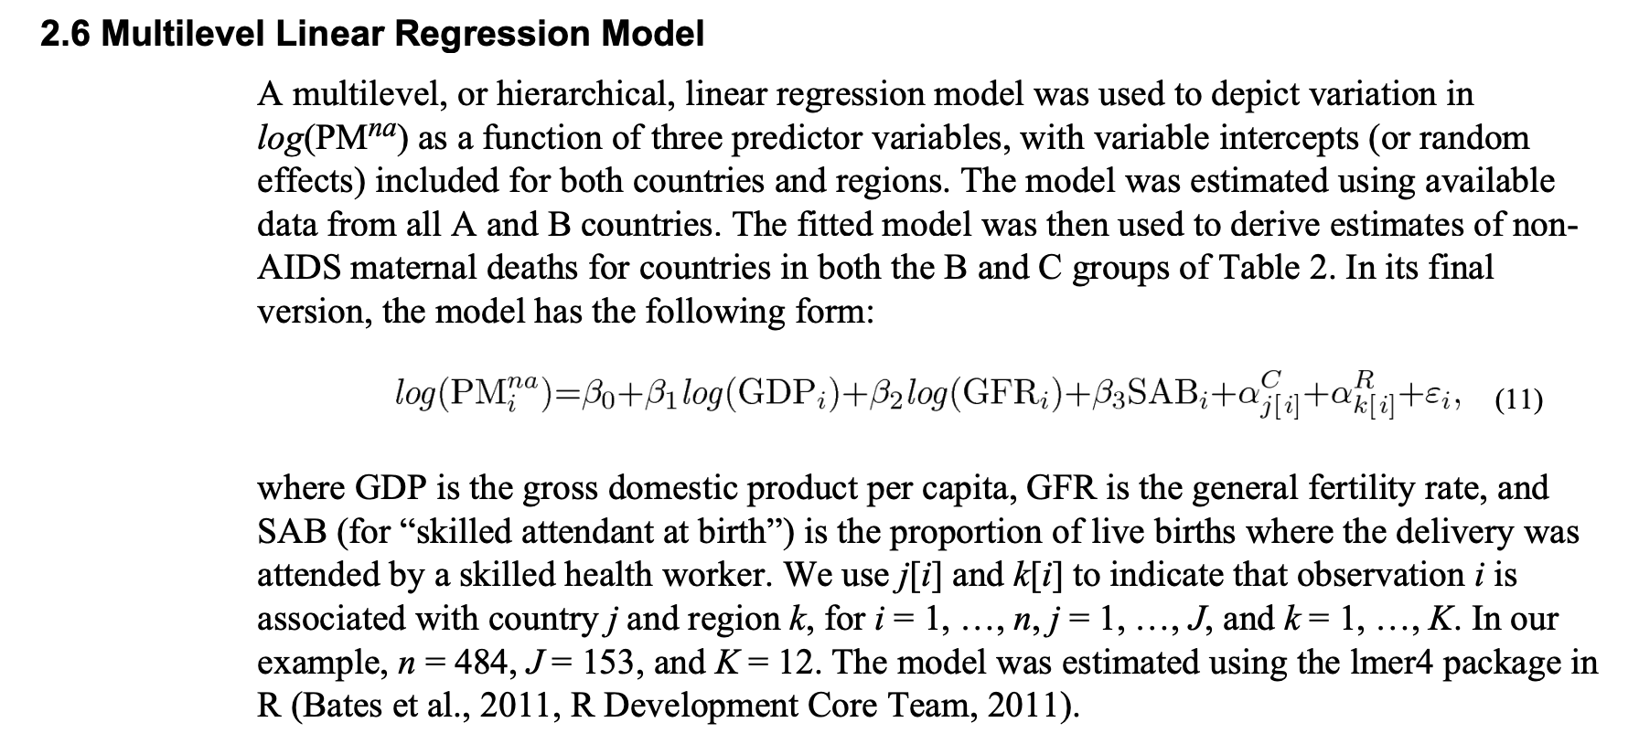 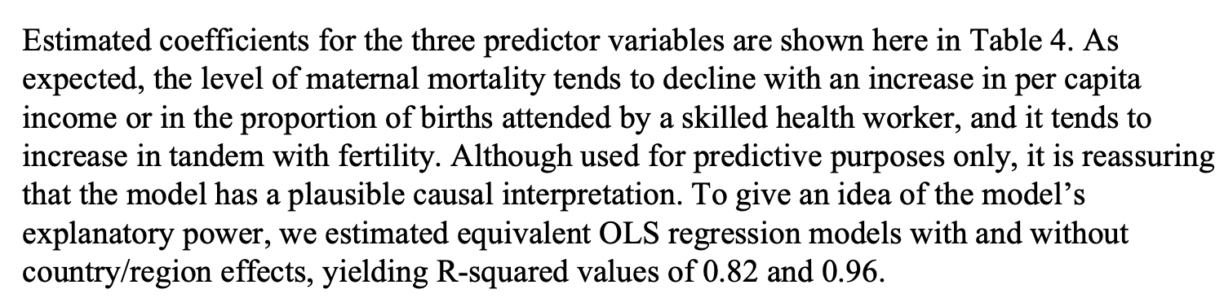

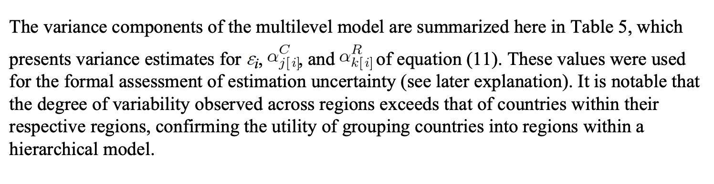

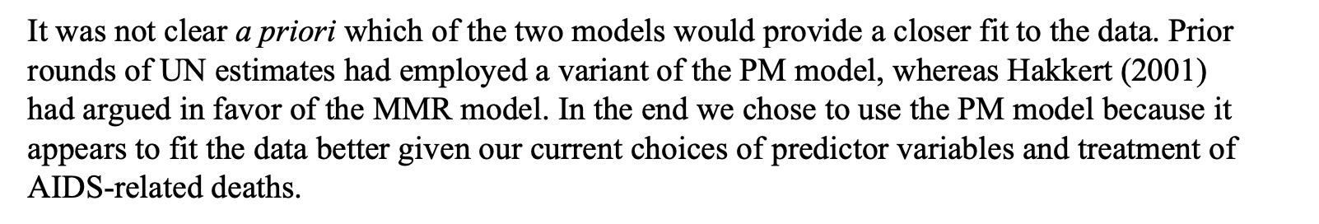

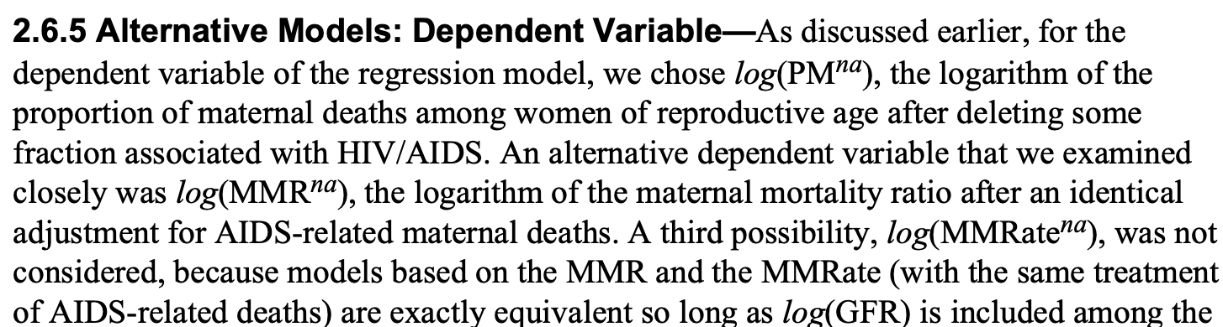

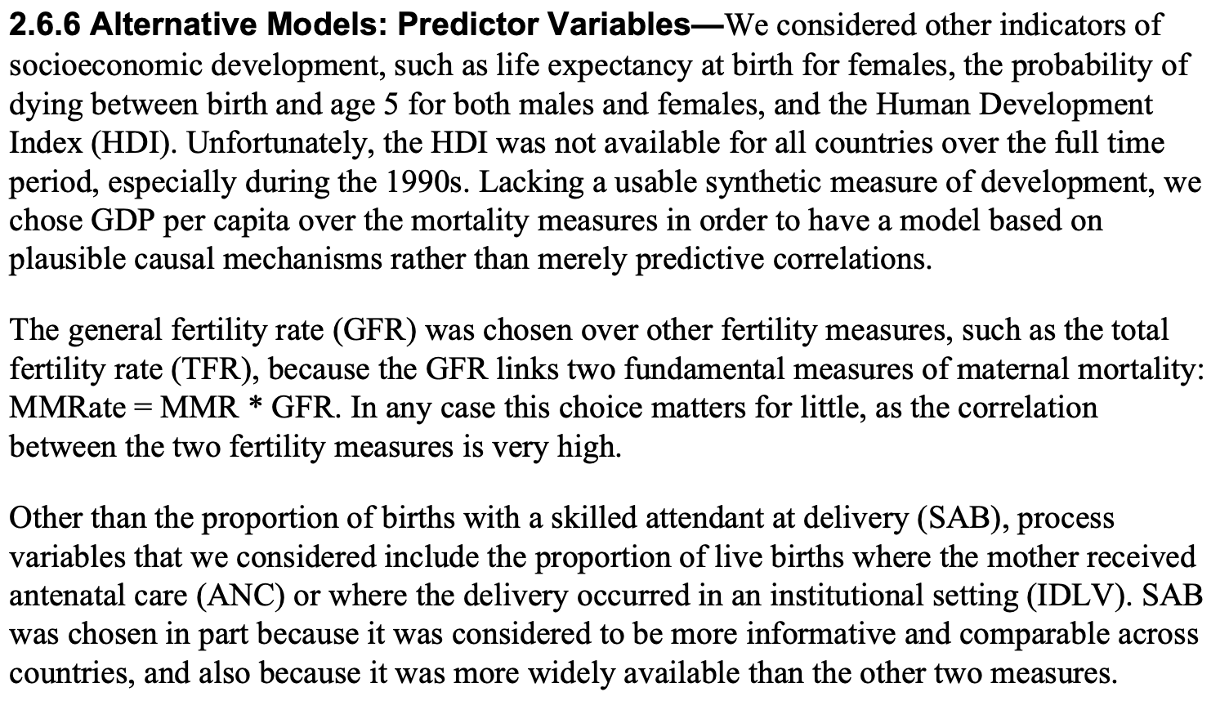

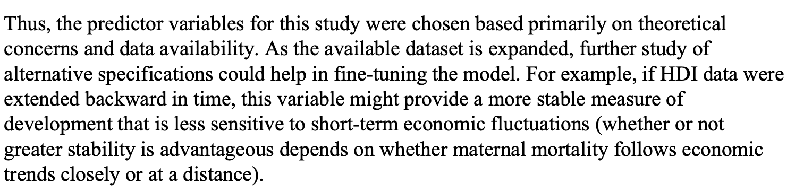



* Justification for my model choice? Especially for including more features

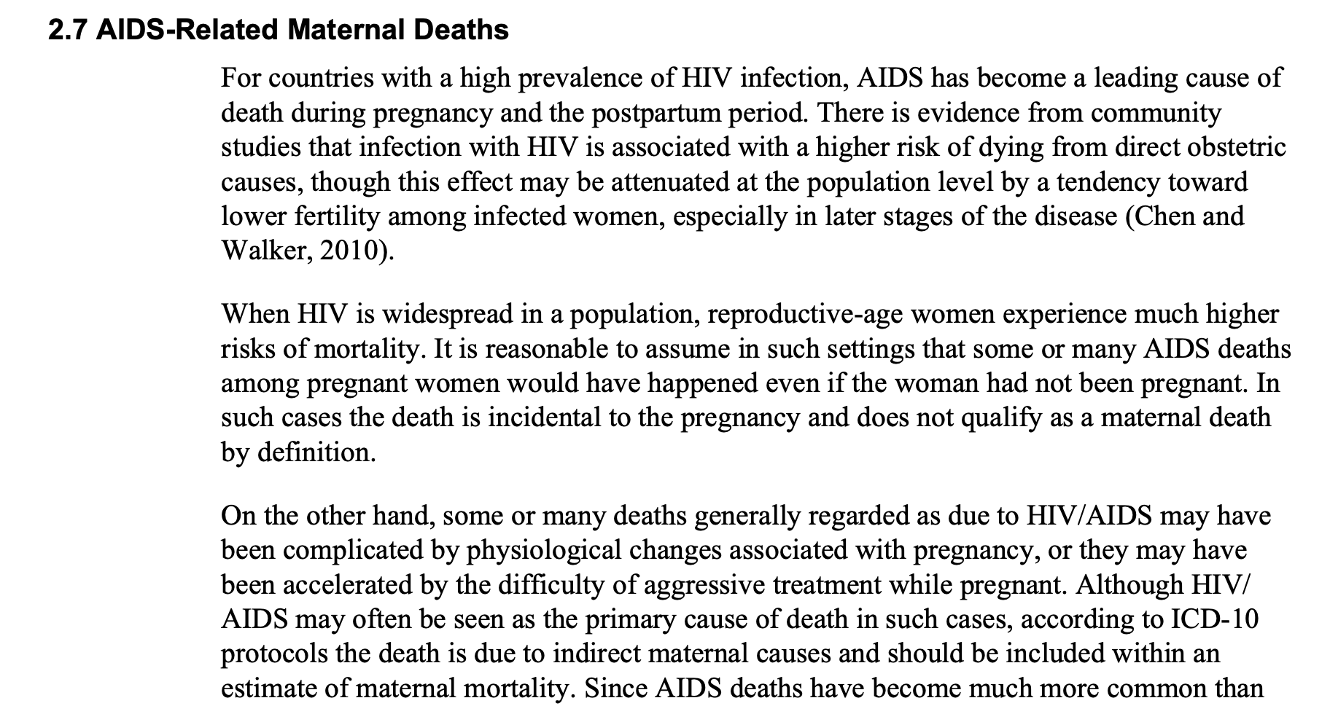 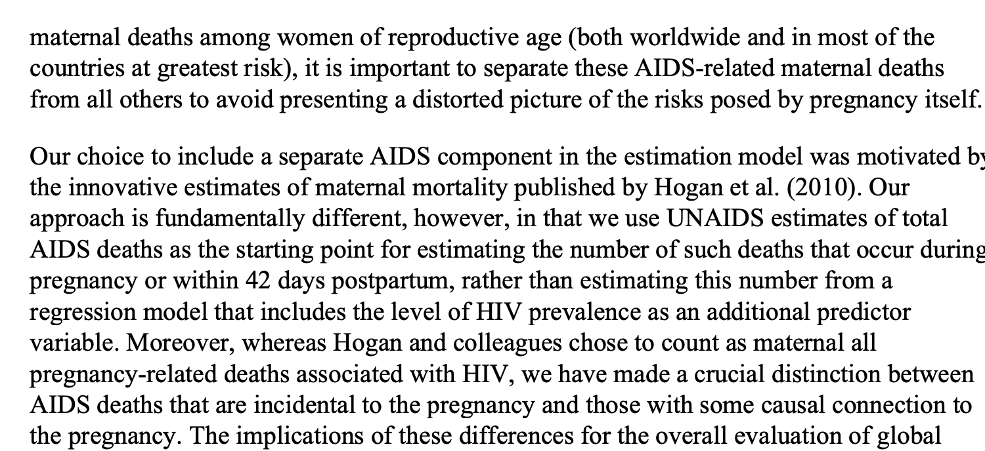

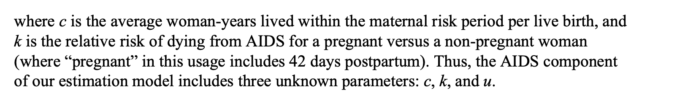

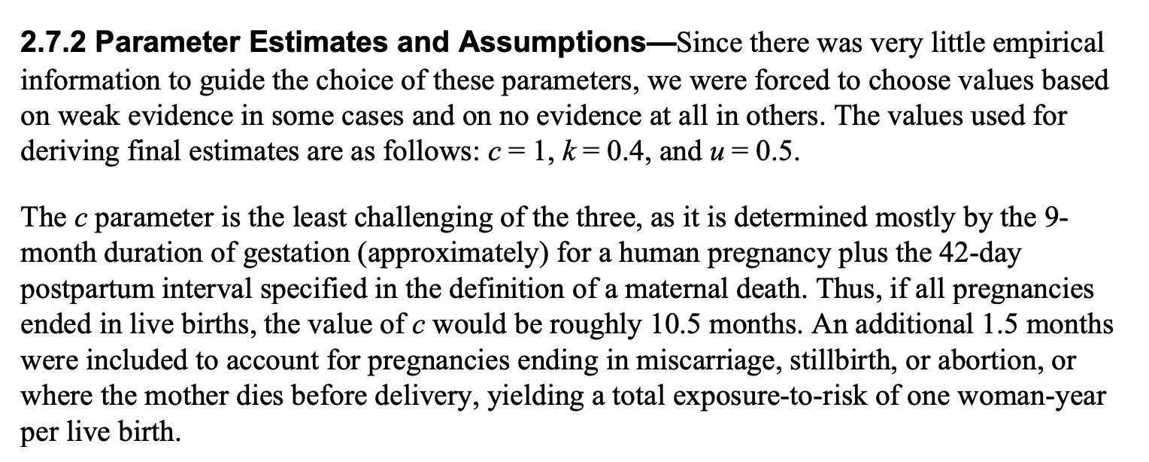

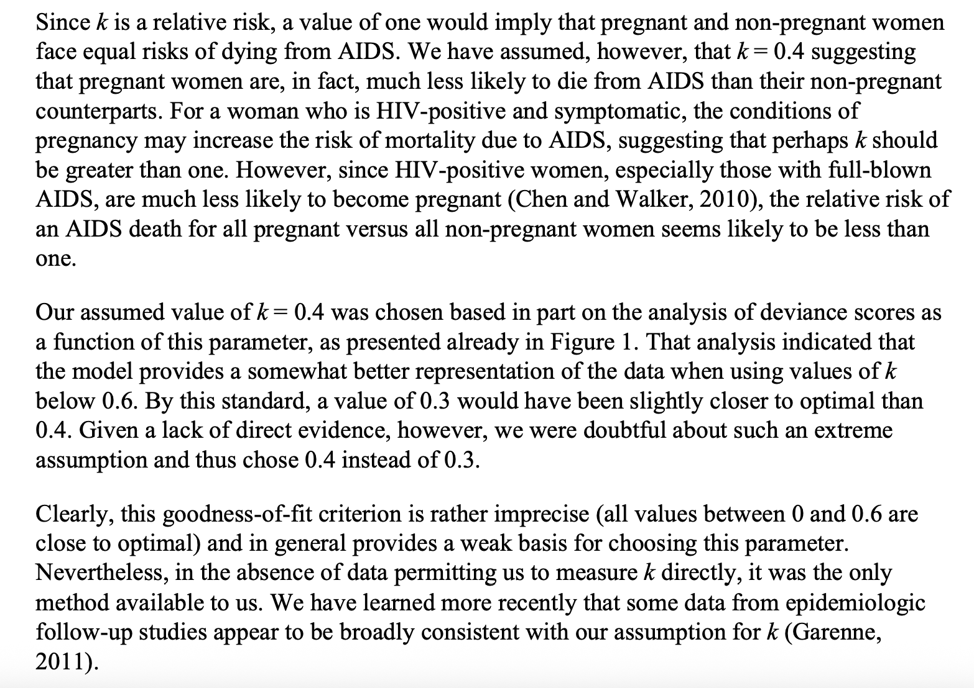 - could this difficulty choosing parameters for the model motivate use of machine learning instead?

- who chose k and u values based on prior studies and data analysis

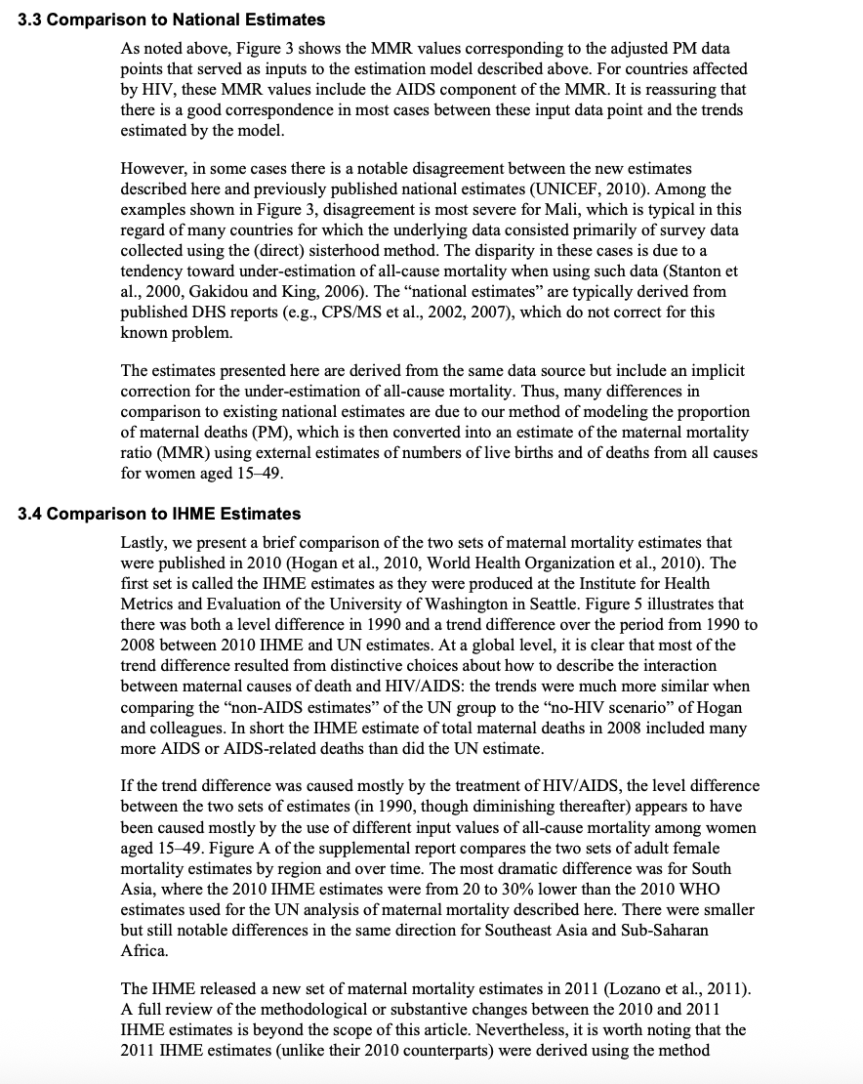

## Bayesian Approach to MMR Estimation

<https://projecteuclid.org/journals/annals-of-applied-statistics/volume-11/issue-3/A-Bayesian-approach-to-the-global-estimation-of-maternal-mortality/10.1214/16-AOAS1014.full>

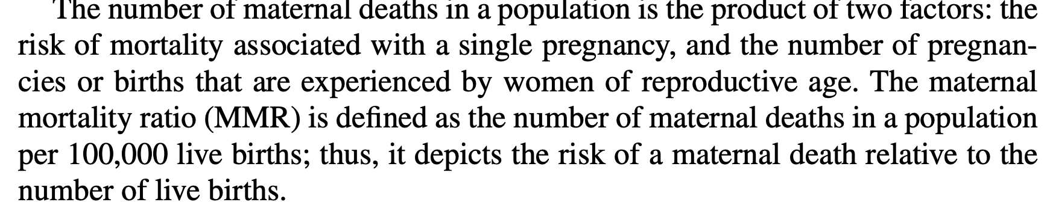

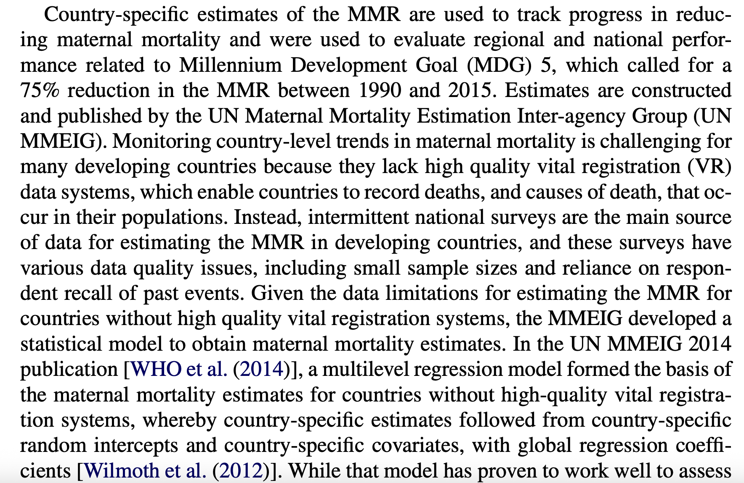

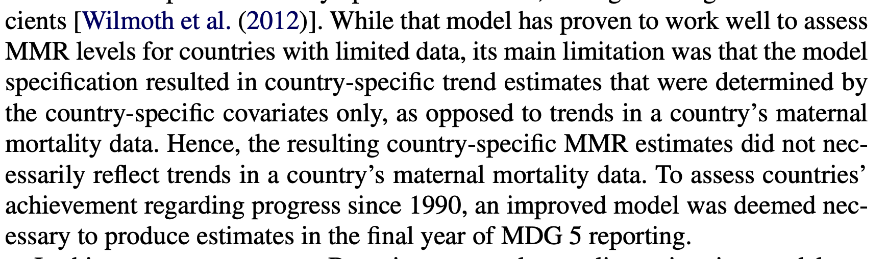

* This is the method discussed in the who report, where there is a data-driven indicator that corrects for trend in MMR

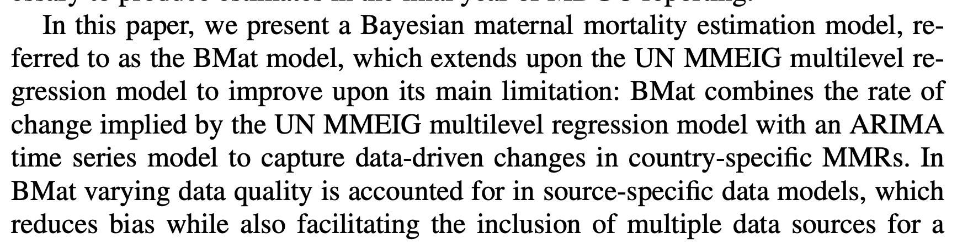

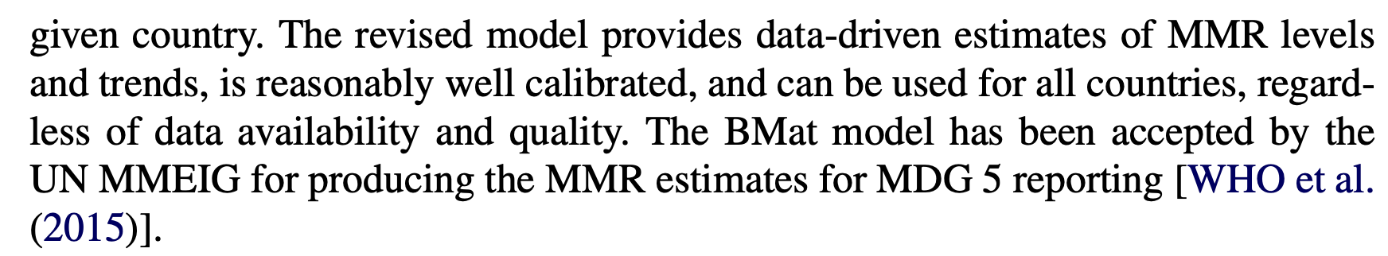

Hoping that these patterns can be learned by the machine learning models?

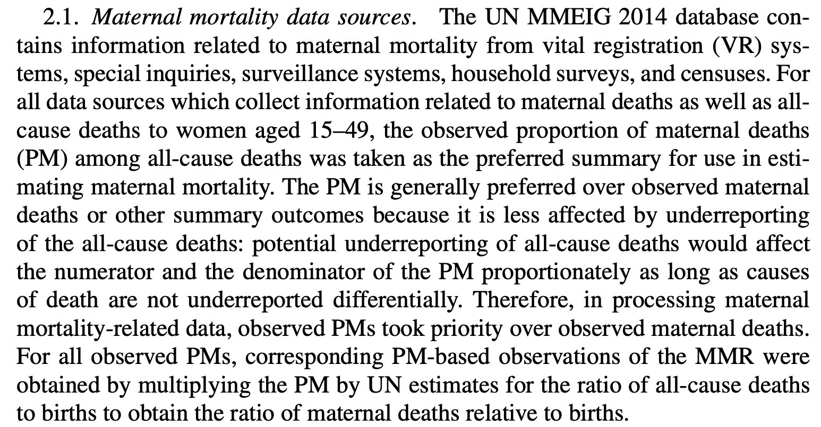

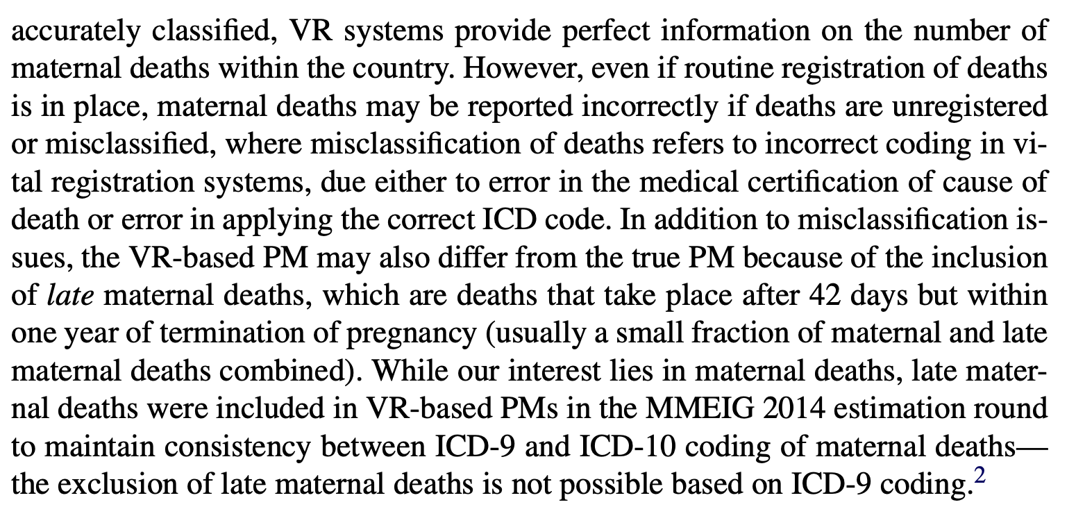

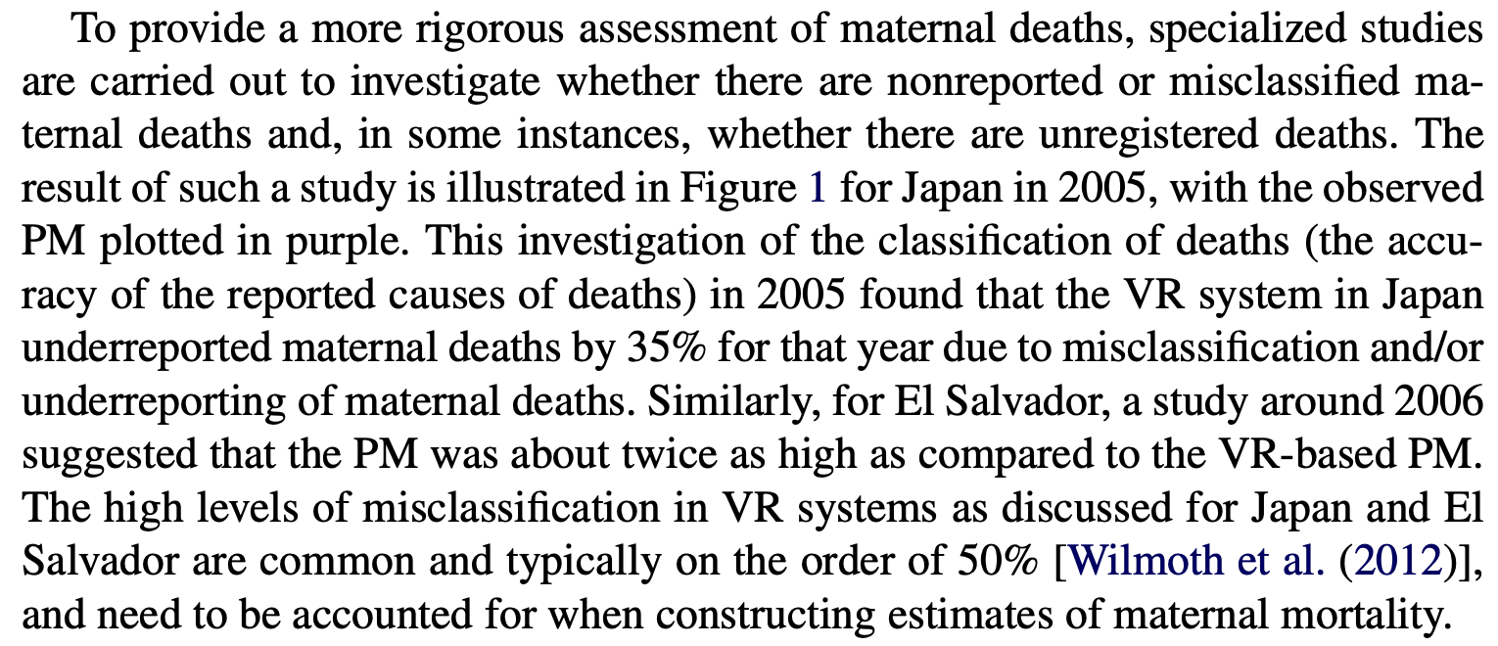

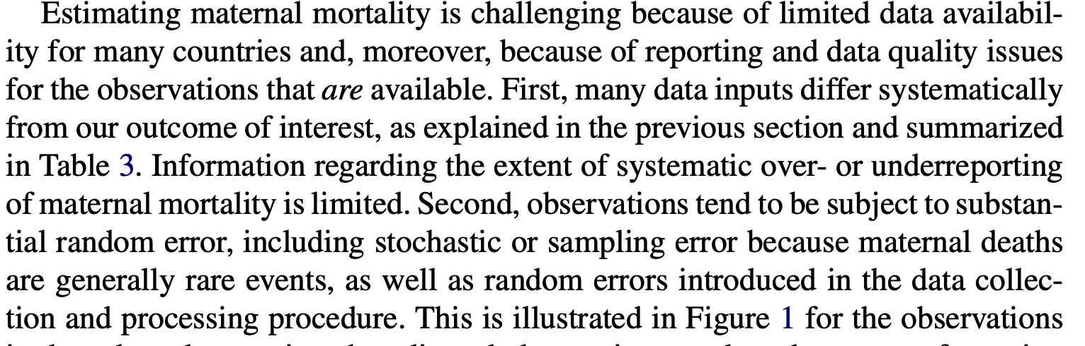 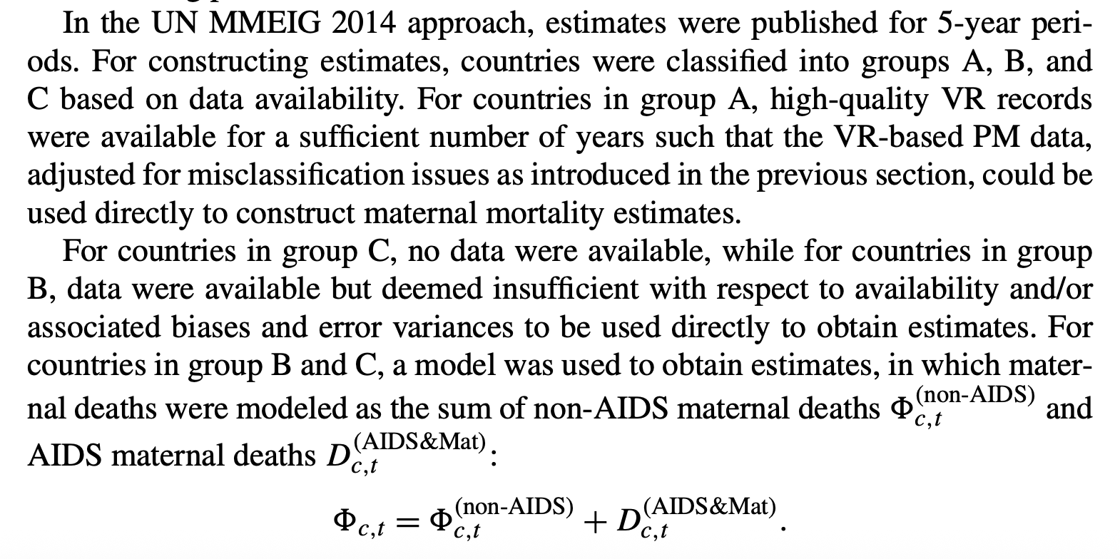 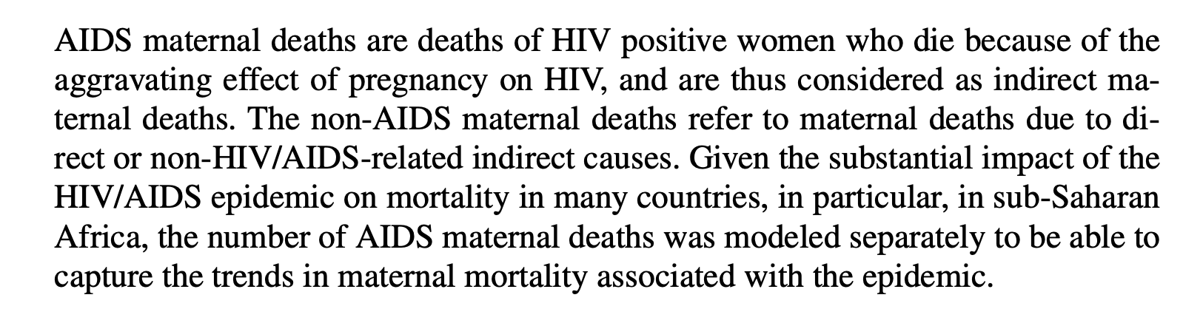 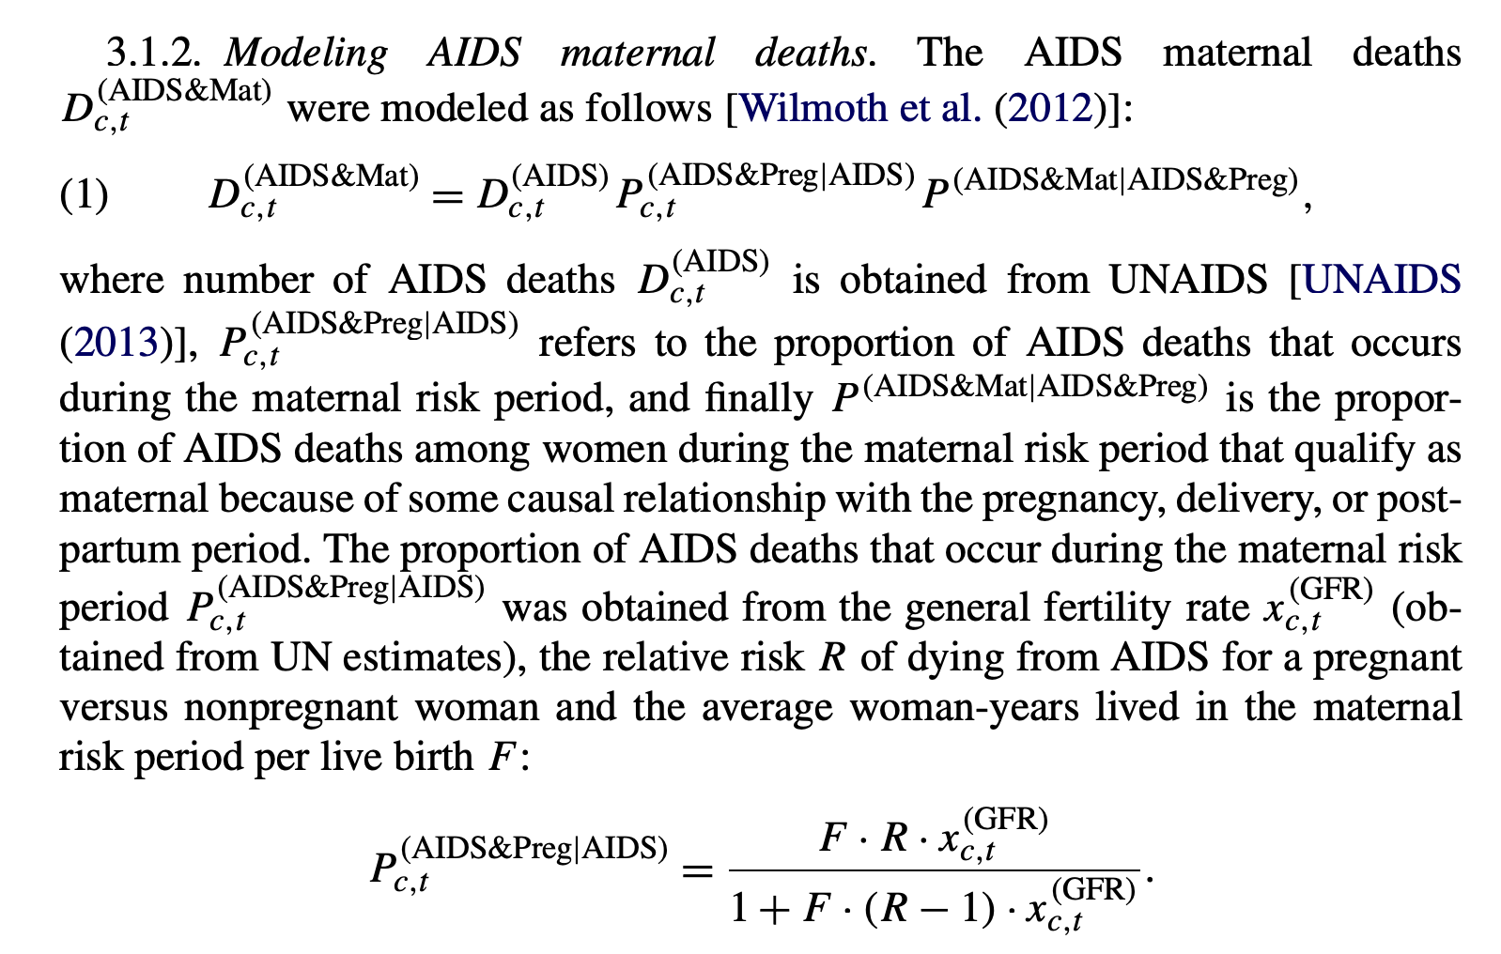 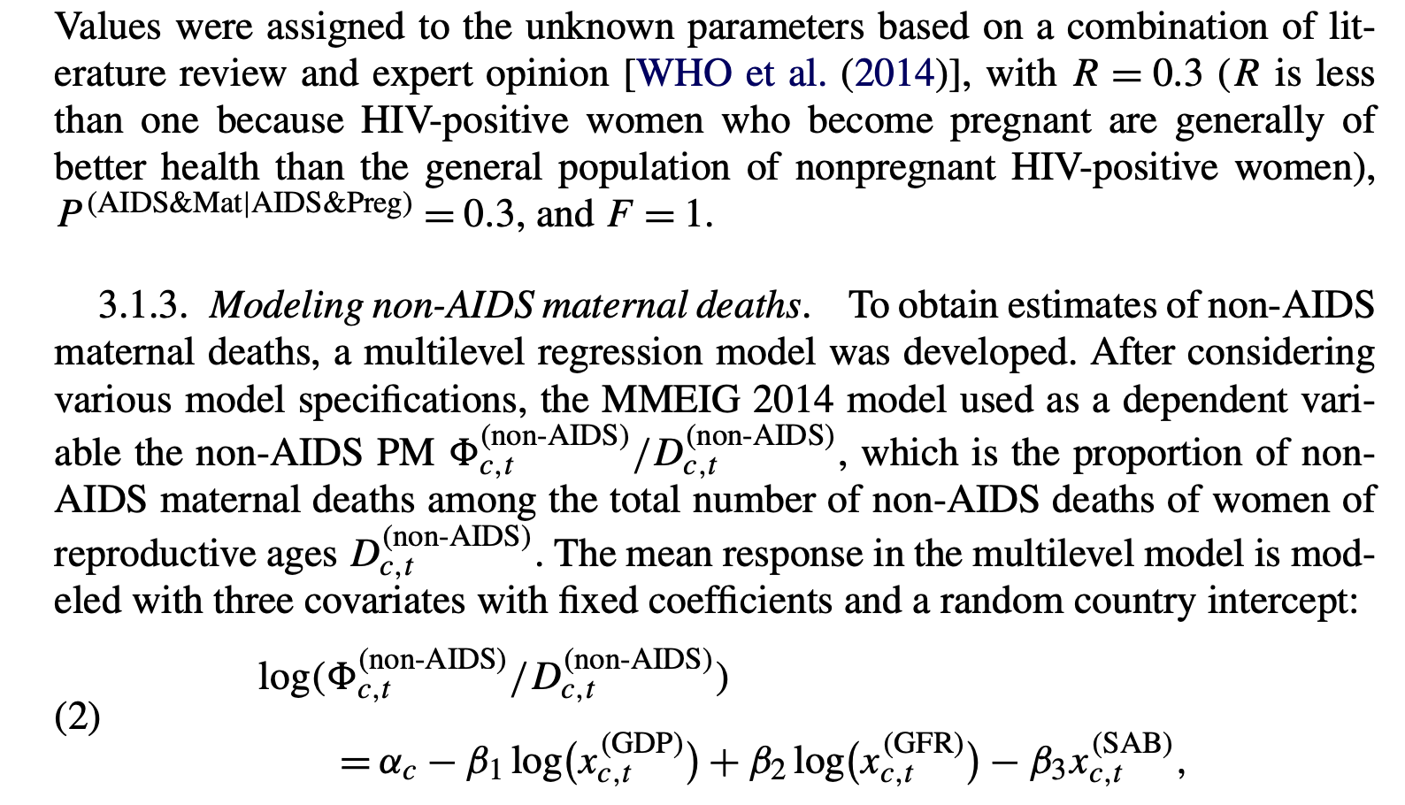 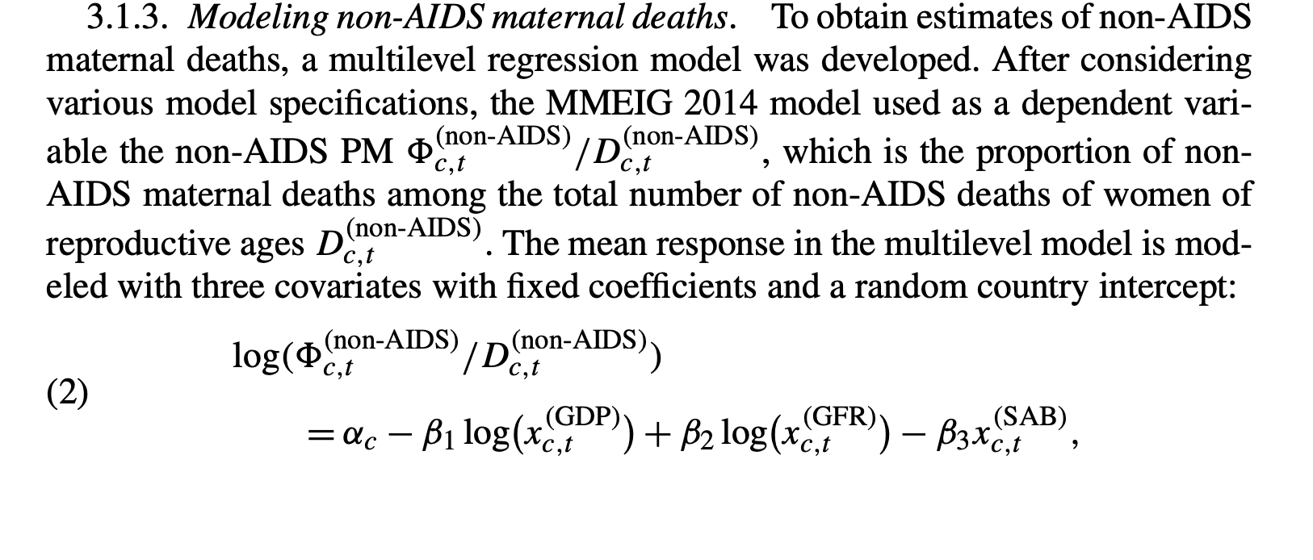

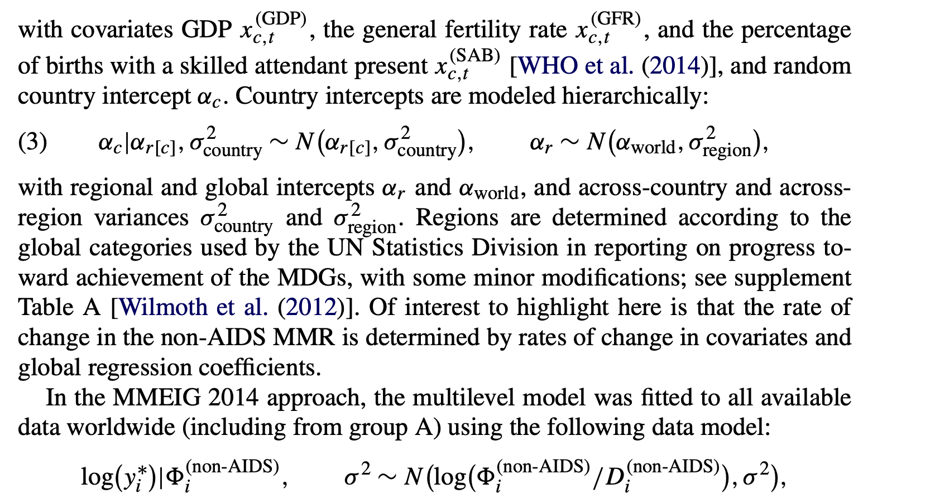

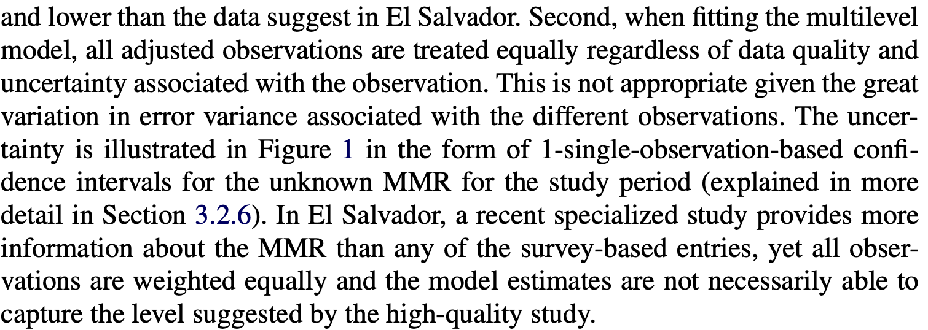

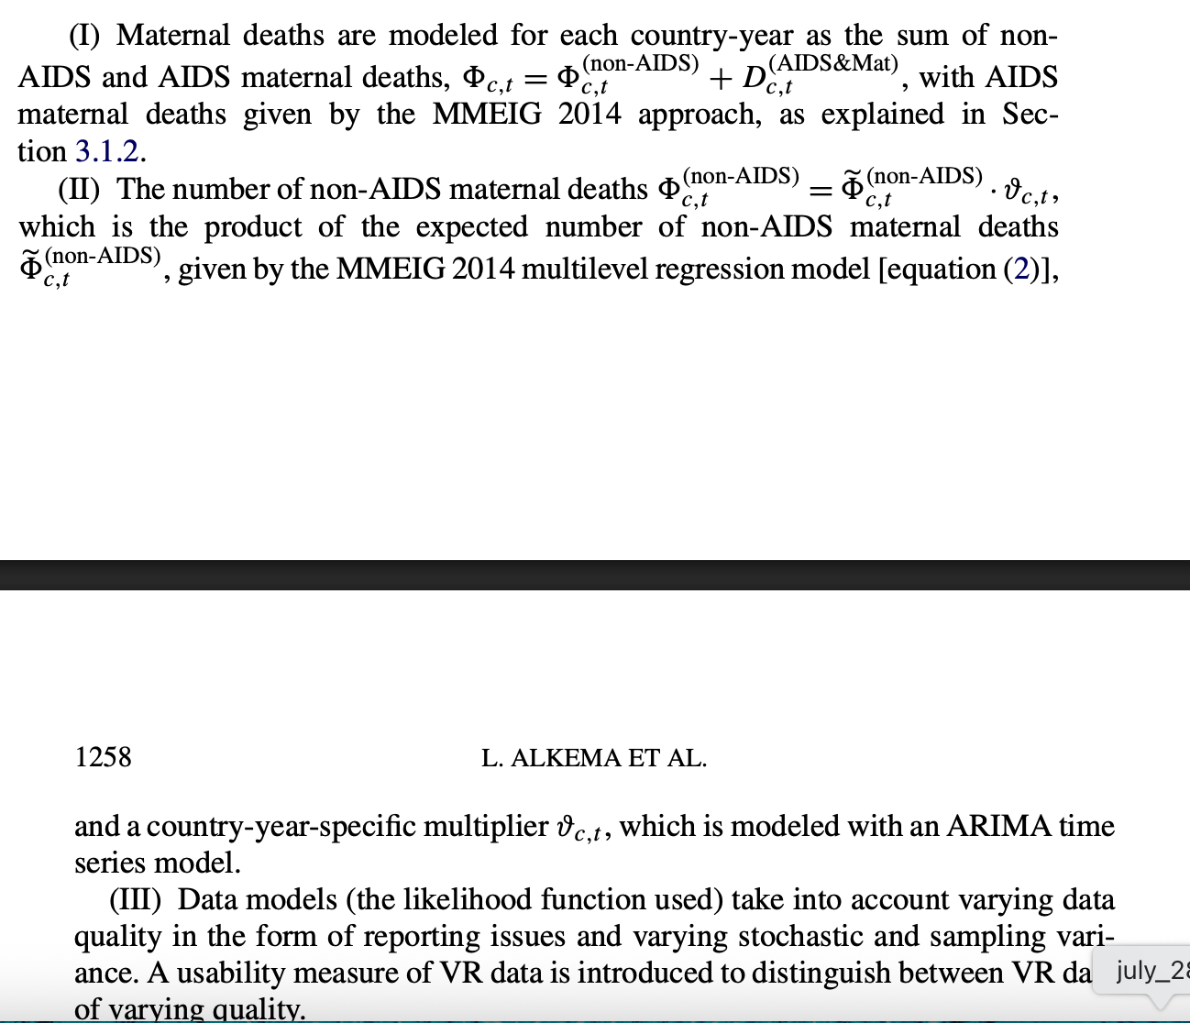

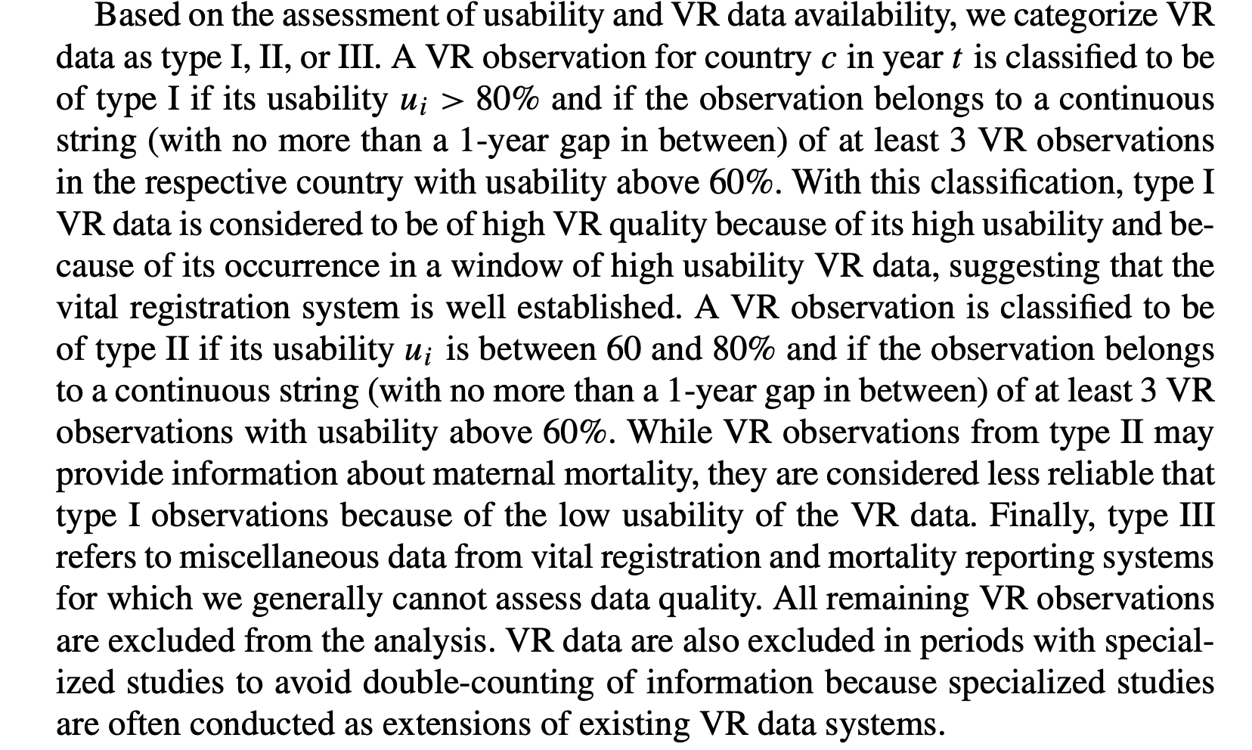

* I have more missing data in my samples than allowed by these authors

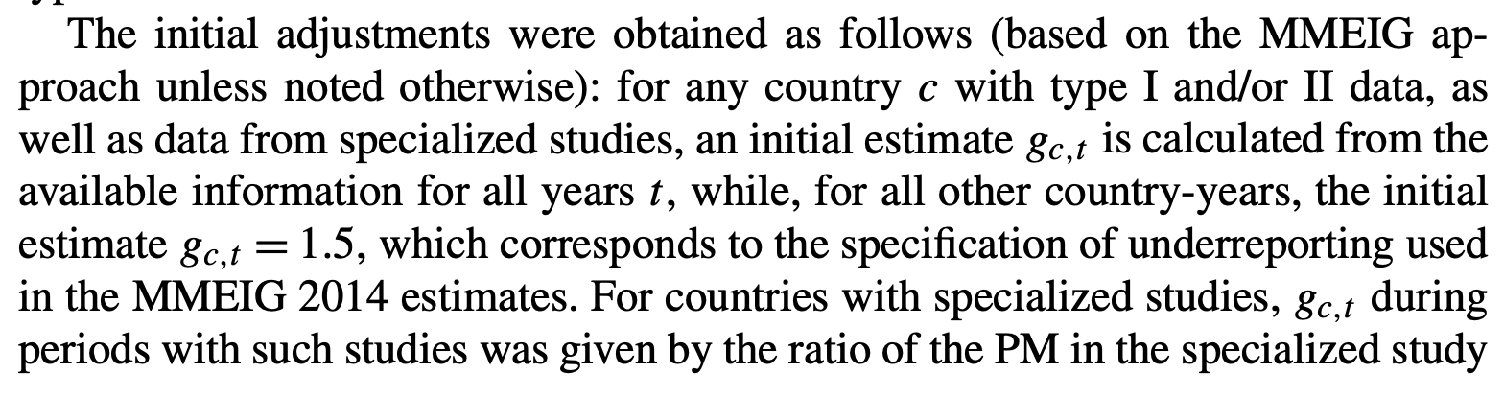

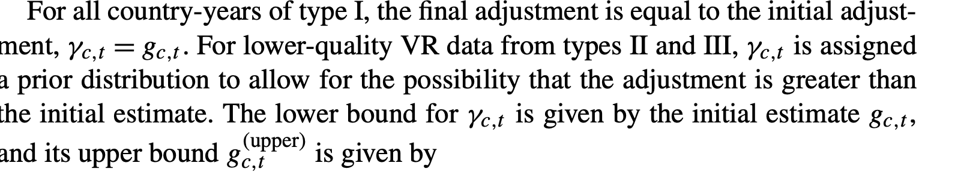

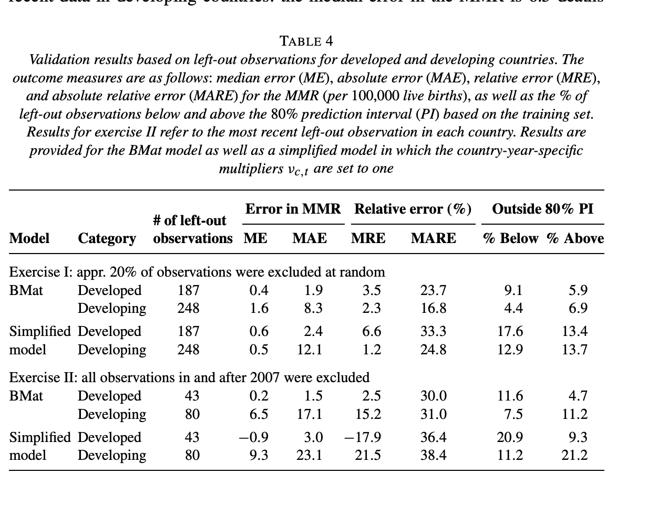 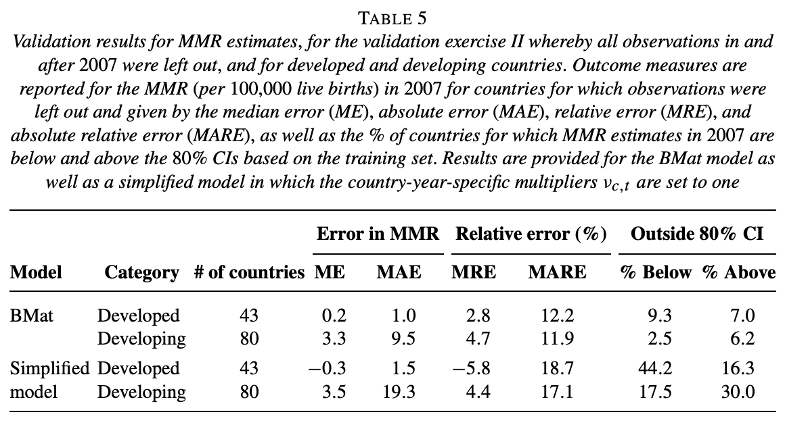

Hierarchy comes from: estimate region trends compared to global (intercept), and then the country trends compared to global (another intercept)

## Principles of multilevel modelling

<https://academic.oup.com/ije/article/29/1/158/666823>

